Week 4 Assignment 1 of 1
Supply & Demand: Equilibrium
Scenario
Suppose that you are the manager of the campus bookstore and your primary responsibility is to set the prices of textbooks in a manner which keeps the store shelves well stocked while keeping students satisfied.
Every week you receive a shipment of new books from the book publishers. The number of books the publishers are willing to deliver to the bookstore depends upon the price you set for the book.
In setting the price of this book you’re provided with the publisher’s weekly supply schedule and an estimate of student’s weekly demand. The following supply and demand schedules are for the book “The Murmur of Bees” by Sofia Segovia.
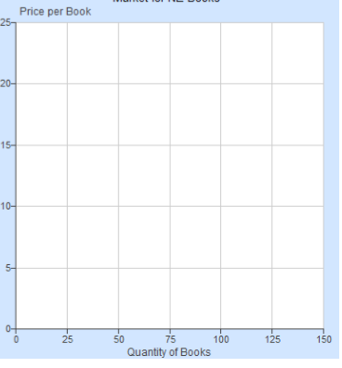
Directions:
- Begin by plotting the weekly supply and demand curves for this book.
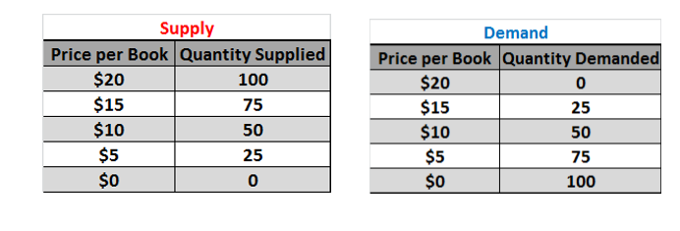

2. Suppose that assistant manager initially sets the price of the book at $20 because he claims that it will, “maximize revenue for the bookstore.” Is he right? How many books will be sold at this price?
Hint 1: To find the quantity demanded at a price, read the demand schedule or demand curve.
Hint 2: To find revenue multiple the quantity demanded by the price.

3. What sort of situation would be created if the price were $20, a surplus or a shortage of books? Exactly how much of a weekly surplus or shortage?

4. How would you, as the bookstore manager, respond to this situation? (No, you can’t fire your assistant manager). What would happen to the quantity of books supplied and demanded as you made this change?

5. Suppose you lower the price of the book to $15, does this help the situation? Does it completely fix it?

6. Suppose you lower the price of the book to only $5, what sort of a situation would this create and would all students be happy with this low price?

7. What price should the book be set at in order to prevent either a surplus or a shortage from resulting and how many books will be exchanged at that price?

Week 5 Assignment 1 of 1
Economics Final Reflection
Directions
COVID-19 has affected the global economy in many ways. Choose four of the following economic concepts or terms that we have studied this semester and apply them to our current economic situation.
Write a detailed but concise example and explanation for each of the FOUR concepts or terms you select.
- Scarcity
- Resources
- Waste
- Innovation
- Labor
- Human capital
- Physical capital
- Price signals
- Demand
- Law of Demand
- Shifts in Demand
- Supply
- Law of Supply
- Shifts in Supply
- Shortage
- Equilibrium
Example

Shifts in Demand
Demand has increased for hand sanitizer at every price point. This means people are willing to buy more sanitizer than they were before at every price point, even when the prices are high. Demand at every price has increased because people are worried about their health and safety as a result the virus COVID-19. This causes a shift in the demand curve, and a new one will need to be created to predict demand at a given price.

