Mrs. Smutny
Intermediate Art
Periods 1, 5
Week of April 20 Assignment

*NOTE*: this assignment is only for students who DID NOT turn in their Pop Art project before school closed! If you already turned in your Pop Art project, do not do this assignment.

Pop Art Review
Directions: Please review the notes on the principle of rhythm below and do the assignment that follows.
NOTES
- Pop Art
  - Began in the mid 1950’s – 1960’s as a response to abstract expressionism
    - Challenged originality and what it means to be an artist because of the appropriation of images
  - Often used parody or irony to comment on commercialism
- Characteristics
  - Use visuals from popular culture (advertising, comic books, mundane objects, labels, celebrities)
  - Exaggeration (bigger, bolder, brighter, repeated)
  - Reference mass production techniques (printmaking, “Benday” dots)
- Example artists:
  - Roy Lichtenstein 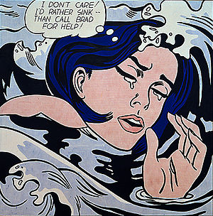 Drowning Girl 1963
    - Subject is from a comic book panel and has been enlarged with bright blue color and bold black outlining. He also uses the printmaking technique of Benday dots in the skin and water.
  - Andy Warhol 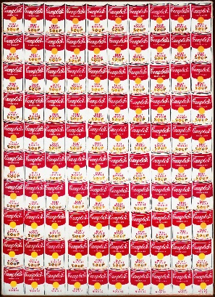 100 Cans 1962
    - Subject is a common Campbell Soup can, seen in every supermarket. To exaggerate it, he repeated the image 100 times and brighten the red and yellow normally found on the labeling. The outlines of the cans are bold. He also used printmaking to recreate the image accurately 100 times.

Assignment 40/40
*NOTE*: Will be converted to a percentage in Aeries (Ex: 30/40pts = 75% or 75/100)
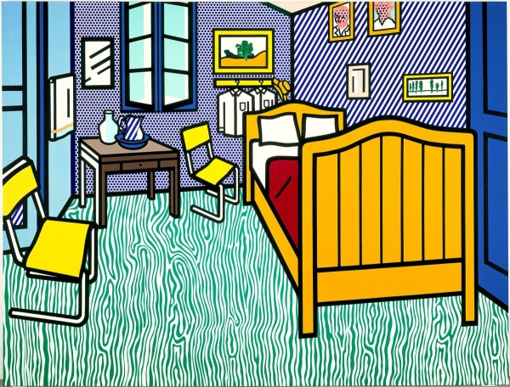

Roy Lichtenstein Bedroom at Arles 1992 (colors: yellow chairs, bed frame, and picture frames; blue walls, door, window and shower frames, pitcher; red blanket; green floor; brown nightstand)

Answer these questions about the above artwork:
- What characteristics of Pop art are used in this piece? Explain these characteristics with details from the artwork.
- Make an interpretation as to the meaning or idea behind the artwork. Use 2 details from the artwork to support your interpretation.
Grading
20pts per question
  - Q1: correctly explains the characteristics of Pop Art in the artwork with clear details for each characteristic
  - Q2: makes an interpretation with at least 2 clear details to support that interpretation
-5 for lack of clarity
-10pts for answering half the question
0pts for totally incorrect answers

Example: Roy Lichtenstein’s Glass with Lemon
- This is an example of Pop Art because the subject are mundane objects, a glass of water and a lemon. He exaggerated the bright yellow of the lemon and used bright blue in the background. He also used thick, bold, black outlining around the objects and graphic black diagonal lines to indicate value.
- I think the idea behind this was to create a graphic version of the still life. Still life paintings are a common subject in art and meant to be realistic. Instead, this one brightens the color of the lemon and repeats it in the mirror. Bright blue was added to contrast the yellow. The bold black highly contrasts the white in the glass making it appear more graphic than real.

