Teacher Name: Dwight Lillie Student Name: ________________________
Class: ELL Chemistry
Period: Period 4
Assignment: Assignment week 4
Due: Friday, 5/15

General Instructions:
Please do the activities for each day as indicated. Any additional paper needed please attach.

Submitted Work:
- Completed packet.

Questions:
Please send email to your instructor and/or attend published virtual office hours.

Schedule:
Date | Activity
Monday (5/11) | Read page 232,233
Tuesday (5/12) | Read and work through problems 1-8
Wednesday (5/13) | Read and work through problems 9-13
Thursday (5/14) | Read and work through problems 14-177
Friday (5/15) | Read and work through problems 18 - 20

Molecular Geometry
How can molecular shapes be predicted using the VSEPR theory?

Why?

When you draw a Lewis structure for a molecule on paper, you are making a two-dimensional representation of the atoms. In reality however, molecules are not flat—they are three-dimensional. The true shape of a molecule is important because it determines many physical and chemical properties for the substance. In this activity you will learn how to predict molecular shapes.

Model 1 – Lewis Structures
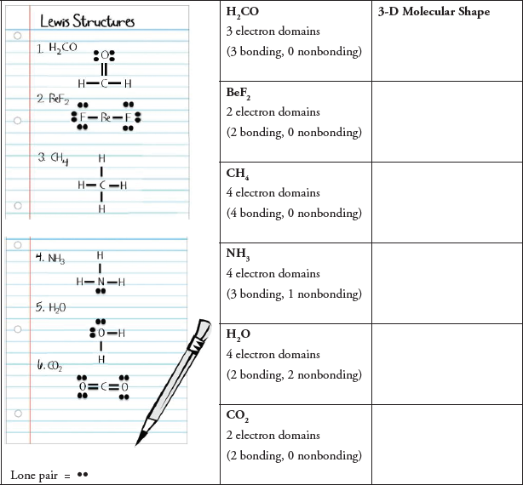

- Name the type of structures shown in the left-hand column of Model 1.

- Examine the drawings in Model 1.
  - What does a solid line between two element symbols represent in the drawings of the molecules?

  - What subatomic particles (protons, neutrons or electrons) make up these solid lines?

  - What does a pair of dots represent in the drawing of the molecules?

  - What subatomic particle (protons, neutrons or electrons) makes up each dot?

- In the English language, what does the word “domain” mean? (Your group must come to consensus on this question.)

- Which molecules in Model 1 have four electron domains? Circle or highlight the four electron domains in the Lewis structure for each molecule that you identified.

- Which molecules in Model 1 have two electron domains? Circle or highlight the two electron domains in the Lewis structure for each molecule that you identified.

- Which molecule in Model 1 has three electron domains? Circle or highlight the three electron domains in the Lewis structure for the molecule that you identified.

- When determining the number of electron domains in a Lewis structure, which of the following should you count? Find evidence from Model 1 to support your answers.
  - Bonds on the center atom c. Lone pairs on the center atom

  - Total number of atoms in the molecule d. Lone pairs on peripheral atoms

- When determining the number of electron domains in a Lewis structure, do you count double bonds as one domain or two domains? Find evidence to support your answer from Model 1.

- Explain the difference between a bonding electron domain and a nonbonding electron domain using the examples in Model 1.

- Circle the correct word or phrase to complete the sentences:
  - Pairs of electrons will (attract/repel) each other.

  - Two bonds on the same atom will try to get as (close to/far from) each other as possible.

  - A lone pair of electrons and a bonded pair of electrons will (push away from/move toward) each other.

Read This!

The VSEPR (Valence Shell Electron Pair Repulsion) Theory helps predict the shapes of molecules and is based on the premise that electrons around a central atom repel each other. Electron domains are areas of high electron density such as bonds (single, double or triple) and lone-pairs of electrons. In simple terms VSEPR means that all electron bonding domains and electron nonbonding domains around a central atom need to be positioned as far apart as possible in three-dimensional space.

- VSEPR theory specifies “valence shell” electrons. Explain why these are the most critical electrons for determining molecular shape based on your exploration of Model 1.

- In the VSEPR theory, what is repelling what?

- Based on the information in the Read This! section, sketch one of the molecular shapes shown below in each of the boxes provided in Model 1.
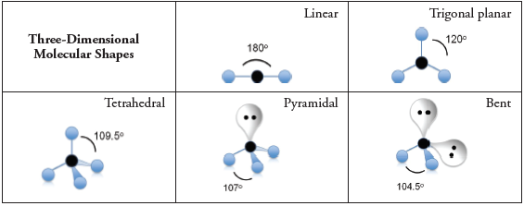

- Often, we draw Lewis structures with 90° bond angles. Do any of the molecular shapes in Model 1 have 90° bond angles?

- Are the bond angles in the three-dimensional molecules generally larger or smaller than those shown in the Lewis structures drawn on notebook paper?

- Why is it possible to get larger angles separating electron domains in three-dimensions versus two-dimensions?

- Identify the three molecules shown in Model 1 that have four electron domains each.
  - What happens to the size of the bond angle(s) in a molecule as the number of lone pairs on the central atom increases?

  - What are some possible explanations for the trend in part a?

- A student does not “waste” his time drawing a Lewis structure before determining the shape of PF3. The student thinks that the shape of PF3 must be trigonal planar because there are three fluorine atoms bonded to the central phosphorus atom.
  - Draw the Lewis structure for PF3.

  - Was the student’s answer for the shape of a PF3 molecule correct? Explain.

  - Why is it important to draw the Lewis structure for a molecule before identifying the shape of the molecule?

- Complete the following chart:

Molecule | Lewis Structure | 3-D Drawing | Name of 3-D Shape | Bond Angle
H2S

PH3

CCl4

CS2

Extension Question
- Ozone, O3, is not a linear molecule. Actually it is bent with an angle that is a little less than 120°.
  - Draw the Lewis structure of ozone, O3.

  - Describe why ozone has a bent shape instead of a linear shape.

  - Describe why ozone’s bond angle is larger than that of water, H2O.

