Teacher Name: Lillie Student Name: __________________________

Class: CP/NGSS Chemistry

Period: Period 1, 2, 3, 6

Assignment: Assignment Week 5

***Due: Friday, 5/22. ***Not Collected\*\*\****

# Stoichiometry (mole to mole ratios and simple one step problems)

## General Instructions:

Please do the activities for each day as indicated. You will work the problems on separate sheets of paper as necessary that you will attach to the completed packet that you submit. Be sure your name is on all sheets of paper. Follow your individual teachers’ instructions for turning in work

## Submitted Work:

1. Reading notes from section 12.1 & 12.2
2. Completed practice problems and section assignments below

## Questions:

1. Please send email as you have questions and/or attend virtual office hours.

|  |  |
| --- | --- |
| Date | Activity |
| Monday (5/4) | Read Section 12.1  Take reading notes.  Be able to work through all sample problems. |
| Tuesday (5/5) | Read Section 12.2  Take reading notes.  Be able to work through all sample problems. |
| Wednesday (5/6) | Practice Problems 11 & 12 (page 360 of text) *show all of your work* |
| Thursday (5/7) | Practice Problems 13 & 14 (page 361 of text) *show all of your work* |
| Friday (5/8) | Practice Problems 15 & 16 (page 364 of text) *show all of your work* |

*Answers to problems problems can be found in “appendix E” at the back of your book*

**Examples and set ups *(how to show your work)***

**Mole ratios from a balanced equation**

Given the following equation: **2C4H10 + 13O2 🡪 8CO2 + 10H2O**, show what the following molar ratios should be.



1. C4H10 *and* O2



1. C4H10 *and* CO2

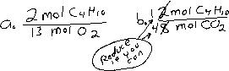

1. C4H10 *and* H2O

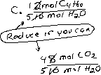

1. O2 *and* CO2



1. O2 *and* H2O
2. CO2 and H2O

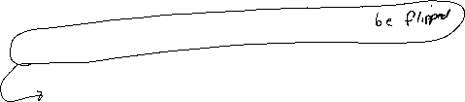

**Mole to mole conversion from a balanced equation**

Given the following **BALANCED** equation: **2KClO3 🡪 2KCl + 3O2**

* How many moles of O2 can be produced by letting 12.00 moles of KClO3 react?

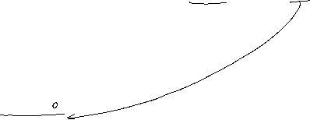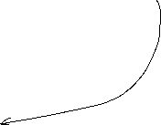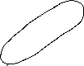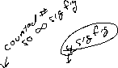

**Grams to grams conversion from a balanced equation *(will require 2 steps and molar masses)***

Given the following equation: **2K + Cl2 🡪 2KCl**

* How many grams of KCl is produced from 2.50 g of K and excess Cl2.

