KIRK BROWN SCHOLARSHIP
Biology, Biotech, &/or STEM Education focused
$250
First Name______________________________Last Name______________________________________

Mailing Address:_________________________________________________________________________

City_____________________________State_________________Zip Code__________________________

Home Phone# ( )_________________Cell #( )_______________DOB________Age____Sex M F X

ACADEMIC INFORMATION:
Cumulative Grade Point Average___________
- Attach a screen shot of your GPAs part of your transcript. Please feel free to “black out” personal details in first section
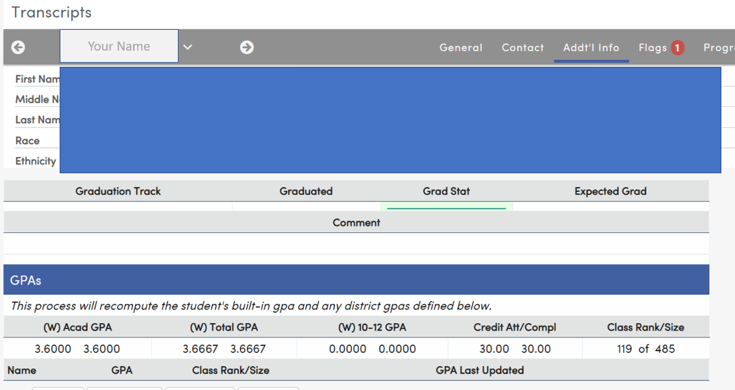replace ex w/ yours
Are you in: AVID_____ IB_____ CTE_____ Ag Science________

What Voc. Ed, Junior College, College or University do you plan to attend next fall?
1st Choice: _______________________________________________________________________________
2nd Choice: ______________________________________________________________________________
Your field of study/current interest:________________________________________________________
Where do you see yourself in 10 years (30 words or less):
____________________________________________________________________________________________________________________________________________________________________________________

APPLICANT’S FAMILY:
Parent(s) Name(s)___________________________________ _____________________________________

Any relevant family information (20 words or less…ex: first to go to college, to go to college in USA, to pursue a STEM degree/career family caring for grandparent(s)/dependent adult(s), 2 or kids in college)
____________________________________________________________________________________________________________________________________________________________________________________

FINANCIAL DATA:

Will you be applying for financial aid? Yes______ No______
(If you don’t qualify for FASFA type financial aid due to technicality, not financial details, check “yes.” Ex: Dreamers.)

Will you be living at home? Yes______ No______

Please describe any unusual financial circumstances :_______________________________________
______________________________________________________________________________________
______________________________________________________________________________________
______________________________________________________________________________________

On the following page list your activities and interests.

STEM
List all STEM classes that you took at Tracy High
[don’t forget classes like math, computer science welding auto shop also fit here]

Did you take participate STEM enrichment opportunities [ex: online coding classes, Community college classes, etc.
______Yes; ______ No
(if yes, briefly in 30 words or less, describe what it was, its duration, and what you learned)

Describe an “ah ha moment” you have had regarding Biology, Biotech, &/or STEM Education during your high school years (these are not limited to classes or clubs at Tracy high)
[SHORT paragraph]

COMMUNITY SERVICE:
______Yes; ______ No
(if yes, briefly in 30 words or less for each, describe what it was, its duration, and what you learned from the experience. Limit 3!)

SCHOOL: (include student body offices, class offices, clubs-memberships and any offices held activities of specialized nature such as athletic, music, drama, speech, journalism, etc.)
Choose the top 3 most important to you. briefly in 30 words or less for each, describe what it was, its duration, and what you learned from the experience.
Hobbies & Recreational Preferences:
____________________________________________________________________________________________________________________________________________________________________________________
__________________________________________________________________________________________

Qualifications for nominee to apply include:
- Graduating Senior
- Intent to enroll in an accredited institution of higher learning for STEM related studies/career
- On a separate sheet of paper write your educational and career goals

RETURN COMPLETED APPLICATION TO : emckay@tusd.net
ON OR BEFORE April 11, 2022

