Ms. Cornish-Bowden Film Studies Week 3 due no later than 5/15/20

Movie Posters Recreated with Family Members and Household Items
Get creative with items on hand!

Even though most of us are stuck at home during Coronavirus quarantine and can’t go out and enjoy movies in theaters, that doesn’t mean that life has to be boring. What I would like you to do is have fun recreating a poster from one of your favorite movies (PG 13, PG, G or NR) in which you use your family members, pets and props that you have in your home.

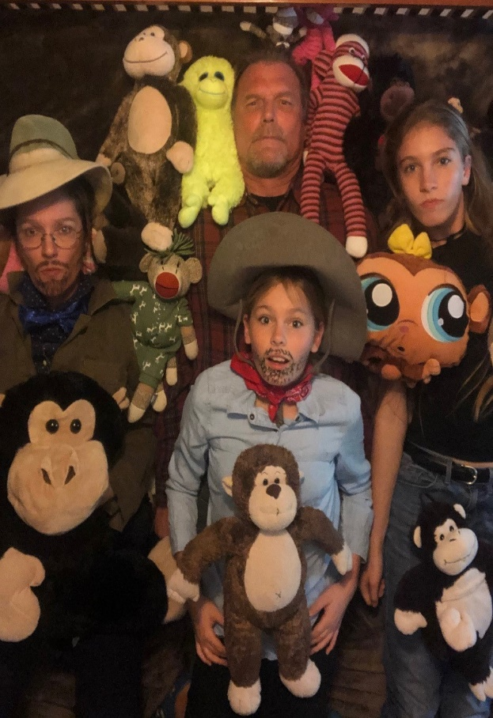
DWAYNE JACK KEVIN KAREN
JOHNSON BLACK HART GILLAN

THE NEXT LEVEL

JUMANJI
Original Movie Poster Jumanji the Next Level (left) and Ms. Cornish-Bowden’s recreation of the movie poster (right) using members of her family and items found in her home.

I don’t have a selfie stick so I attached my phone to the ceiling fan with rubber bands, set the timer, then we laid on the bed with the monkeys and tried to capture the actor’s facial expressions.

Objective: To recreate a movie poster using family members and objects and props that you have in your home.

If you don’t have access to the internet select one of the posters from the four choices on the second page and recreate it using family members and objects you have in your home. After you have recreated the poster with objects make a graphite drawing of your poster on an 8”x11.5” piece of paper. Make sure you write your name on the back of your drawing and the title of the movie that inspired your recreation. Alternatively, if you have a smartphone camera take a photo. You may want to take several and pick the best one. Email your best photo to jbowden@tusd.net In addition, email a photo of the poster that inspired your re-creation.

To get credit you must include your name and period number in the subject line. In addition, email Ms. Cornish-Bowden a photo of the poster that inspired your re-creation.

Tips for the Assignment:

Pose 3 Objects, Pets, or People
Now that you’ve found your inspiration, pick the objects you’d like to use. Any objects are fine: from a blank piece of paper to your
most elaborate hat. You can stick to 3 and see what you come up with but you’re welcome to use as many as you like.
Enlist a pet (or stuffed toy). Get your dogs, cats and bunnies into the mix.
Make a face, strike a pose. If there are people in your poster pay attention to the facial expressions—they really make it. If you’re reenacting a scene with multiple figures, pay attention to the poses.
Pay attention to make-up and costumes. Be inventive with costumes and make-up.
Think abstractly. If you’re having trouble re-creating a poster’s appearance, try focusing on shapes over colors.

If you don’t have access to the internet use one of these posters and recreate using family members and objects in your home. Make a graphite drawing of your poster and turn it in to the office at THS. Note: if you DO have access to the internet you can use one of these four posters or find one that you prefer online.

