Mrs. Smutny
Introduction to Art
Periods 3, 4, 6
Week of April 27 Assignments

Directions: Please review the notes on the principle of emphasis below and do the assignments that follow.
NOTES
- Principle of emphasis
  - One part of the composition dominates (stands out) over the other(s).
  - Focal point: first thing in a composition that attracts the viewer; emphasizes an area of importance
- Ways to create emphasis
  - Use mostly one element of art
Squares and rectangle shapes are dominating the drawing
  - Use contrast: create a big difference among elements (dark vs. light, straight vs. curve
The white triangle stands out because it is lighter than the other triangles.
  - Use isolation: putting something alone
The circle stands out because it is separate from the other shapes.
  - Use location: place it in the center of the composition
The blob shape stands out because it is in the middle.
  - Use convergence: use lines that point at it
The star stands out because the diagonal lines point at it.
  - Use the unusual: add something unexpected
The upside-down guy stands out because he’s on his head, which is odd & unusual.
Assignment 1: 12pts Draw your own examples of each of the 6 techniques.
Assignment 2: 20/20pts Analysis

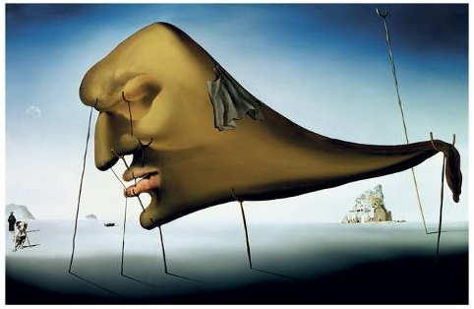
Salvador Dali Sleep 1937

Analyze the use of emphasis by completing these sentence starters: (See example below)
  - The emphasis is ____________(what stands out or is the most important part?).
  - To create it, Salvador Dali used _______ (which techniques)_ by _______(specify what the artist did)__. {Hint: There may be more than 1 technique!}

Grading: 10pts per question
- Q1: correctly identifies the emphasis
- Q2: correctly identifies the techniques clearly & correctly describes where in the artwork each technique occurs
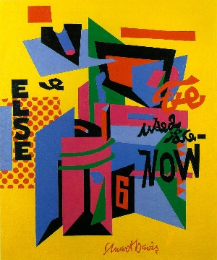
-2 for lack of clarity; -5pts for answering half the question; 0pts for totally incorrect answers
Example for Assignment 2:
- The emphasis in Stuart Davis’ Owh! In San Pao is the collection of blue and red-violet geometric shapes.
- To create it, Davis used location by centering the shapes in the middle. He also used contrast by choosing a lighter color, yellow to surround the darker, blue shapes.

Assignment 3 10/10pts: Summary
- What is emphasis?
- How can you create it?

Extra Credit Assignment 10pts
- Create an artwork with an emphasis using 1 or more of the six techniques (What do you want to stand out and be seen first? Which techniques will you use to do that?)
- Can be done using any medium you have; minimum size: 8 ½”x 11” with a ½” border
- Grading
  - Composition (5pts): effective use of emphasis, all areas considered
  - Workmanship (5pts): careful and precise use of chosen medium with ½ inch border
Mrs. Smutny
Introduction to Art
Periods 3, 4, 6
Week of May 4 Assignments

Directions: Please review the notes on the principle of unity below and do the assignments that follow.
NOTES
- Principle of Unity
  - Sense of oneness or completeness in a composition
    - All parts seem to belong together visually
    - If changes were made it would change how good it looks and/or it would changes the meaning or idea behind the artwork
- How to create unity
  - Use simplicity: limit the variety of elements
The shapes are all the same color, so the element of color has been simplified.
  - Use repetition: repeat an element
There are different sized and colors of circles, so the element of shape is repeated.
  - Use proximity: cluster very different parts and surround with negative space
The various shapes are clustered together in close proximity and look like they belong together.
Assignment 1: Draw your own examples of the techniques to create unity. (6 pts)
Assignment 2: Summary (10pts)
- What is unity?
- How can you create it?
Assignment 3: (10pts) Analyze the use of unity in Wayne Theibaud’s Cakes by completing these sentence starters:
- Unity is created through _(what technique)_ .
- Wayne Theibaud did this by _(specify what the artist did)_.
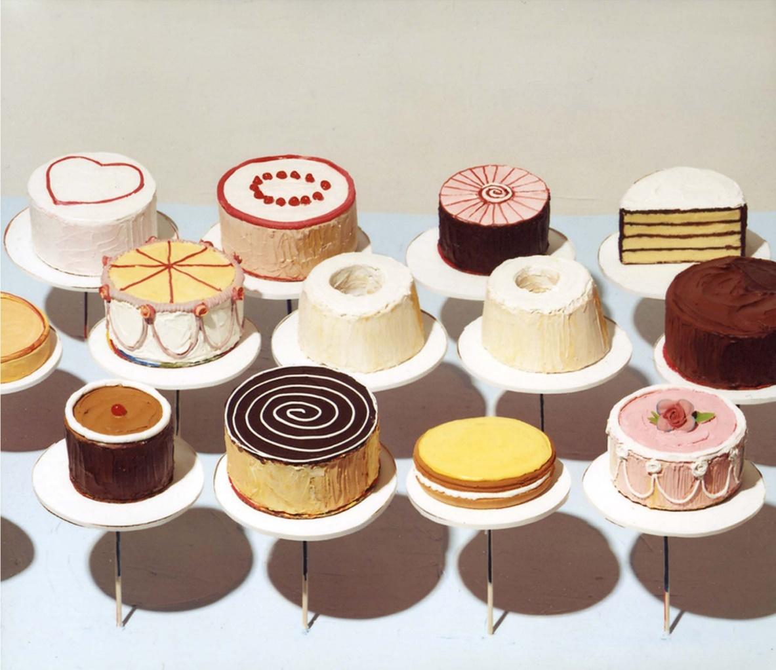 Wayne Thiebaud Cakes 1963

Example for Assignment 3
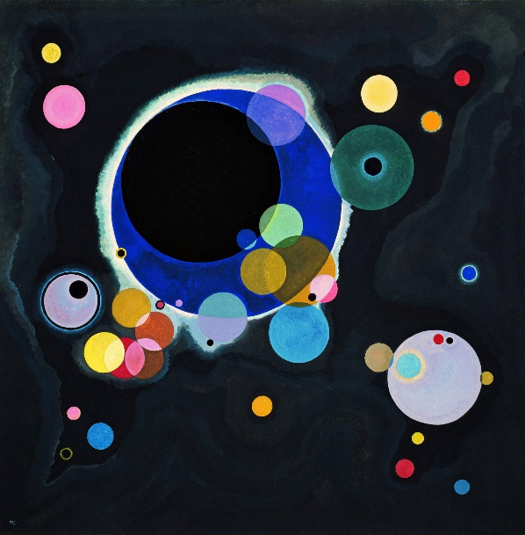 Wassily Kandinsky Several Circles 1926
- Unity is created through repetition and simplicity.
- Wassily Kandinsky did this by repeating the circle shape in different sizes, colors, and values throughout the painting. He also simplified the element of shape by only using circles.

Extra Credit Assignment (10pts)
- Create a unified artwork using 1 or more of the 3 techniques.
- Can be done using any medium you have; minimum size: 8 ½”x 11” with a ½” border.
- Grading
  - Composition (5pts): effective use of unity, all areas considered
  - Workmanship (5pts): careful and precise use of chosen medium with ½ inch border

