Module 1 Assignment 1
Watch the Khan Academy Video linked below and then answer the following questions on demand. STOP when the video starts discussing supply. If you cannot watch the video, use your textbook or lecture notes.
https://www.khanacademy.org/economics-finance-domain/ap-macroeconomics/basic-economics-concepts-macro/demand/v/law-of-demand
- What is the law of demand?

- When does a change or shift in demand occur?

- Summarize each of the determinants of Demand
Price of related goods:

Change in future expectations:

Change in income:

Consumer tastes and preferences

- What is the difference between a change in the quantity demanded and a change in demand?

Directions: Read each scenario and decide if there has been a shift or change in demand. If a shift in demand has occurred, identify which determinant of demand is causing the shift. In which direction (left or right) would the demand curve shift and why?
Demand for Tuna
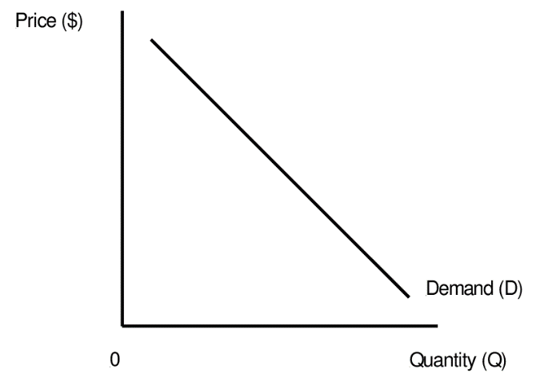
- Shoppers are concerned that they will not be able to leave their houses often due to Covid-19. They go to the store and stock up on cans of tuna.
- Has a change in demand occurred?

- If you answered yes to a, which determinant of demand is causing the shift?

- In which direction (left or right) will the demand curve shift? Why?

