Ms. Cornish-Bowden Film Studies Periods 1, 3 and 6 Assignment Weeks 1 and 2

Television Commercial Assignment- complete all 3 components of this assignment
Dear Students, you were commissioned to create a television commercial for a new product on 3/10/20. You planned your television commercial and script in class prior to the shutdown.

Component 1: Each student needs to turn in the responses to questions 1-5. (Questions listed below; these need to be typed and printed or hand written legibly).
1. List the members in your team – your team members are family members (maximum of 4). What roles will each member play? (E.G. Editor, Cinematographer, Actor, Director). (4 points)
- What is the name of the product? (3 points)
- Who is the intended audience for your product? (3 points)
- Describe Ad: (10 points )
- Which of the persuasive marketing techniques are used? (Involvement technique, emotional needs, buzzwords, association and marketing and/or marketing segmentation.) (5 points)

Component 2: Each student needs to create the product for your commercial –take a photo of your product on your phone and send it to me at: jbowden@tusd.net. Do NOT forget to include your name and period number in the subject line! You need to have a name for the product and create a catchy logo. The product will be graded on its creativity, craftsmanship and overall appearance. (20 points)

Here is an example of a student product that received 100%:
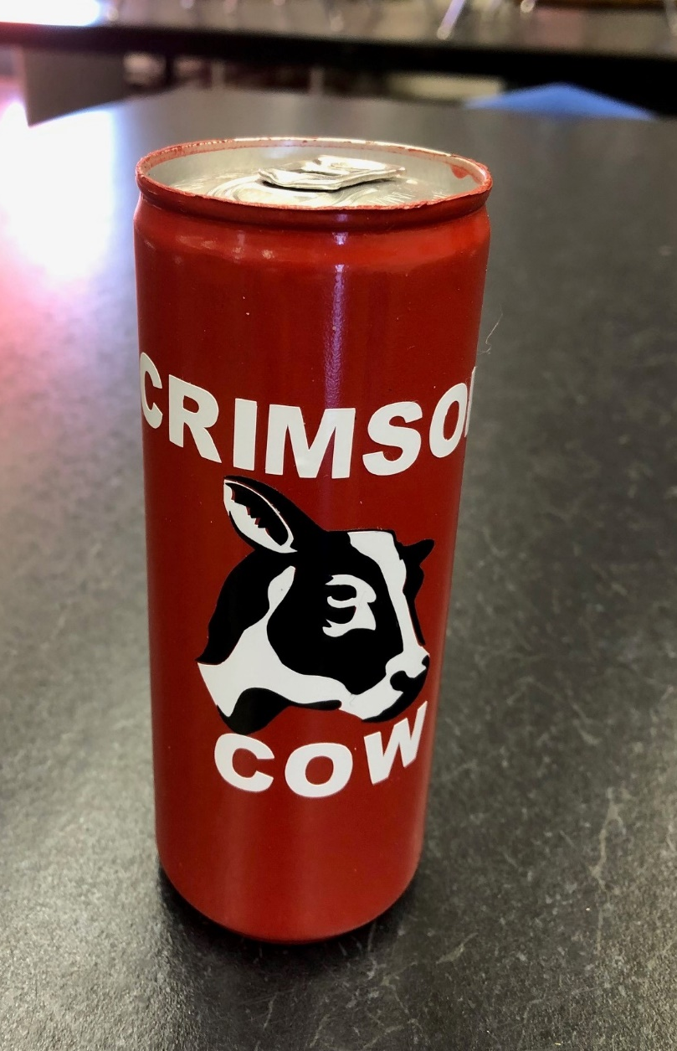
- This product received 100% (25/25)
- Product has a name, “Crimson Cow)
- Product has a catchy logo – Friesian Cow
- The product’s overall appearance is professional
- It has excellent craftsmanship.
- It is original and creative.

Component 3: Due to our current situation you cannot make your commercial with the group you had in class so I am providing 2 options; either:
- Create your commercial at home with your family and upload to YouTube. The You Tube link needs to be Emailed to jbowden@tusd.net. Do NOT forget to include your name and period number in the subject line! The commercial should be about a minute in length and must be no longer than 2 minutes. (25 points)
OR:
- Complete a Story Board (template for story board attached) (25 points)

You have completed Story Boards for previous films. Things to remember:
A storyboard is like a first draft of the film itself. It shows a visual representation of how the film will look and sound.
- In each of the 5 boxes, write down the shot type (e.g. Extreme close-up, establishing shot etc.) and sketch what we will actually see for each frame. If there will be text on the screen, write the text in the box.
- In the dialogue box include any dialogue that will take place “inside” the action or if you will use a “voice-over” to provide background information. Keep dialogue simple and short.
- In the action/music/special effects/lighting box describe any of those elements that apply to that shot.
- Remember to give your film (commercial) a title and write down your name.

Instructions for Planning Your Commercial:
• Identify the issue, idea, or product that will be the focus of your commercial.
• Determine who the intended audience will be. In other words, who might be concerned about the issue you present, or the product you wish to sell?
• Watch a variety of TV commercials and note the most effective strategies used.
• Brainstorm a list of ideas and approaches you might use and select the one that you think might be the most effective. • Develop the strategy that you will use to get the viewers’ attention and to convince them of the importance of your point of view or of your product.

Preparing the Script for Commercial:
• The script should be simple, focused, and use effective language.
• Consider using a catchy slogan that could be repeated in your commercial.
• Identify how many scenes you will have and the kind of camera shots for each.
• Write the script for each scene with reference to points you identified in the outline.
• Decide if the dialogue will take place “inside” the action, or if you will use a “voice-over” to provide background information. Keep dialogue simple and short.
• Create the product for your commercial.
• Keep in mind that most commercials run for only 30 seconds.

The following page has a template for a Story Board. Remember you either create a commercial and send me the YouTube link OR create a Story Board (not both!).

If you choose to create a Story Board either scan a copy of your story board and send me a copy via email or take a photo of your Story Board and send me a copy via email. (jbowden@tusd.net)

Scene  # | Film Title: | Name:
 | Shot Type: | Dialogue:
 |  | Action/Music/Special Effects/Sound Effects/Lighting:
 | Shot Type: | Dialogue:
 |  | Action/Music/Special Effects/Sound Effects/Lighting:
 | Shot Type: | Dialogue:
 |  | Action/Music/Special Effects/Sound Effects/Lighting:
 | Shot Type: | Dialogue:
 |  | Action/Music/Special Effects/Sound Effects/Lighting:
 | Shot Type: | Dialogue:
 |  | Action/Music/Special Effects/Sound Effects/Lighting:

