Cold War Illustrated Timeline Project
DUE DATE: MAY 15^{TH*}

Directions: You will place ALL of the following Cold War Events below in order on a timeline. You will find information on the following events in your notes and textbook. You may also use the internet, if you have access, to research more information if you would like. Your illustrated timelines should be completed on white paper and should include all of the following:
- The correct date(s) in which the event(s) occurred.
- A four-sentence caption summarizing the event.
- A symbol/ or picture to help you remember the significance.
- The symbols/ pictures should be colored.

Cold War Events:
- Yalta Conference | - North Atlantic Treaty Organization (NATO) and Warsaw Pact are created
- The Cold War Begins | - China falls to Communism under leadership of Mao Zedong & the Korean War
- Nuclear Arms Race Begins | - The Second Red Scare and McCarthyism
- Truman Doctrine | - The Lavender Scare
- Berlin Blockade and Airlift | - Sputnik 1 is launched
Example of Illustrated Timeline Project for student reference:

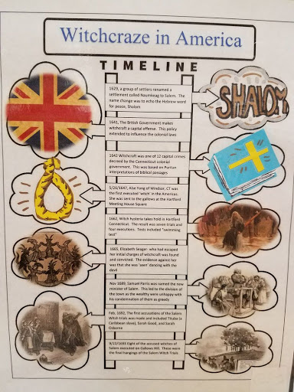
Rubric:

- Includes the correct dates for each event: _______/20 Points
- Includes a four-sentence caption for each event: _______/40 Points
- Includes a symbol/picture for each event: _______/ 20 Points
- Timeline is neat and colorful: _______/ 10 Points
- All information is historically accurate: _______/10 Points

Project Point Total: _________________________________/ 100 Points

