Mr. Paul Demsher
SDC/Survival Math
Period 4
Assignment- Week four and five

Week four and five will be Word Problem Weeks. You will complete word problem worksheets that include concepts we were working on before the break. Your answers and questions can be sent by email to Mr. Demsher at pdemsher@tusd.net or by calling (209) 597-8691 or Mr. Gomez Zavala at jgzavala@tusd.net or by calling (209) 597-8678. Or, you can return hard copies to Mr. Demsher at the school drop-off if you are doing paper copies. Spend only 30 minutes per day on this. Work on as many as you can finish in the 30 minutes you spend on it a day Office hours- AM 9:30-11:00 PM 1:30- 3:00.
Work product/answers should be sent by email or dropped off at school at the end of the week.

Monday, Begin “Addition Word Problems 1”
Tuesday, Finish “Addition Word problems 1” and begin “Subtraction Word Problems 2”
Wednesday, Finish “Subtraction Word Problems 2”
Thursday, Begin “Mixed Addition and Subtraction Word Problems 2”
Friday, Finish any problems from any of the assigned worksheets that are not yet complete

Monday, Begin “Multiplication Word Problems Two”
Tuesday, Finish “Multiplication Word problems Two” and begin “Division Word Problems One”
Wednesday, Finish “Division Word Problems One”
Thursday, Begin “Mixed Multiplication and Division Word Problems 1”
Friday, Finish any problems from any of the assigned worksheets that are not yet complete

You may use the Key Words in Math Problems, sheet to help you complete the assignment
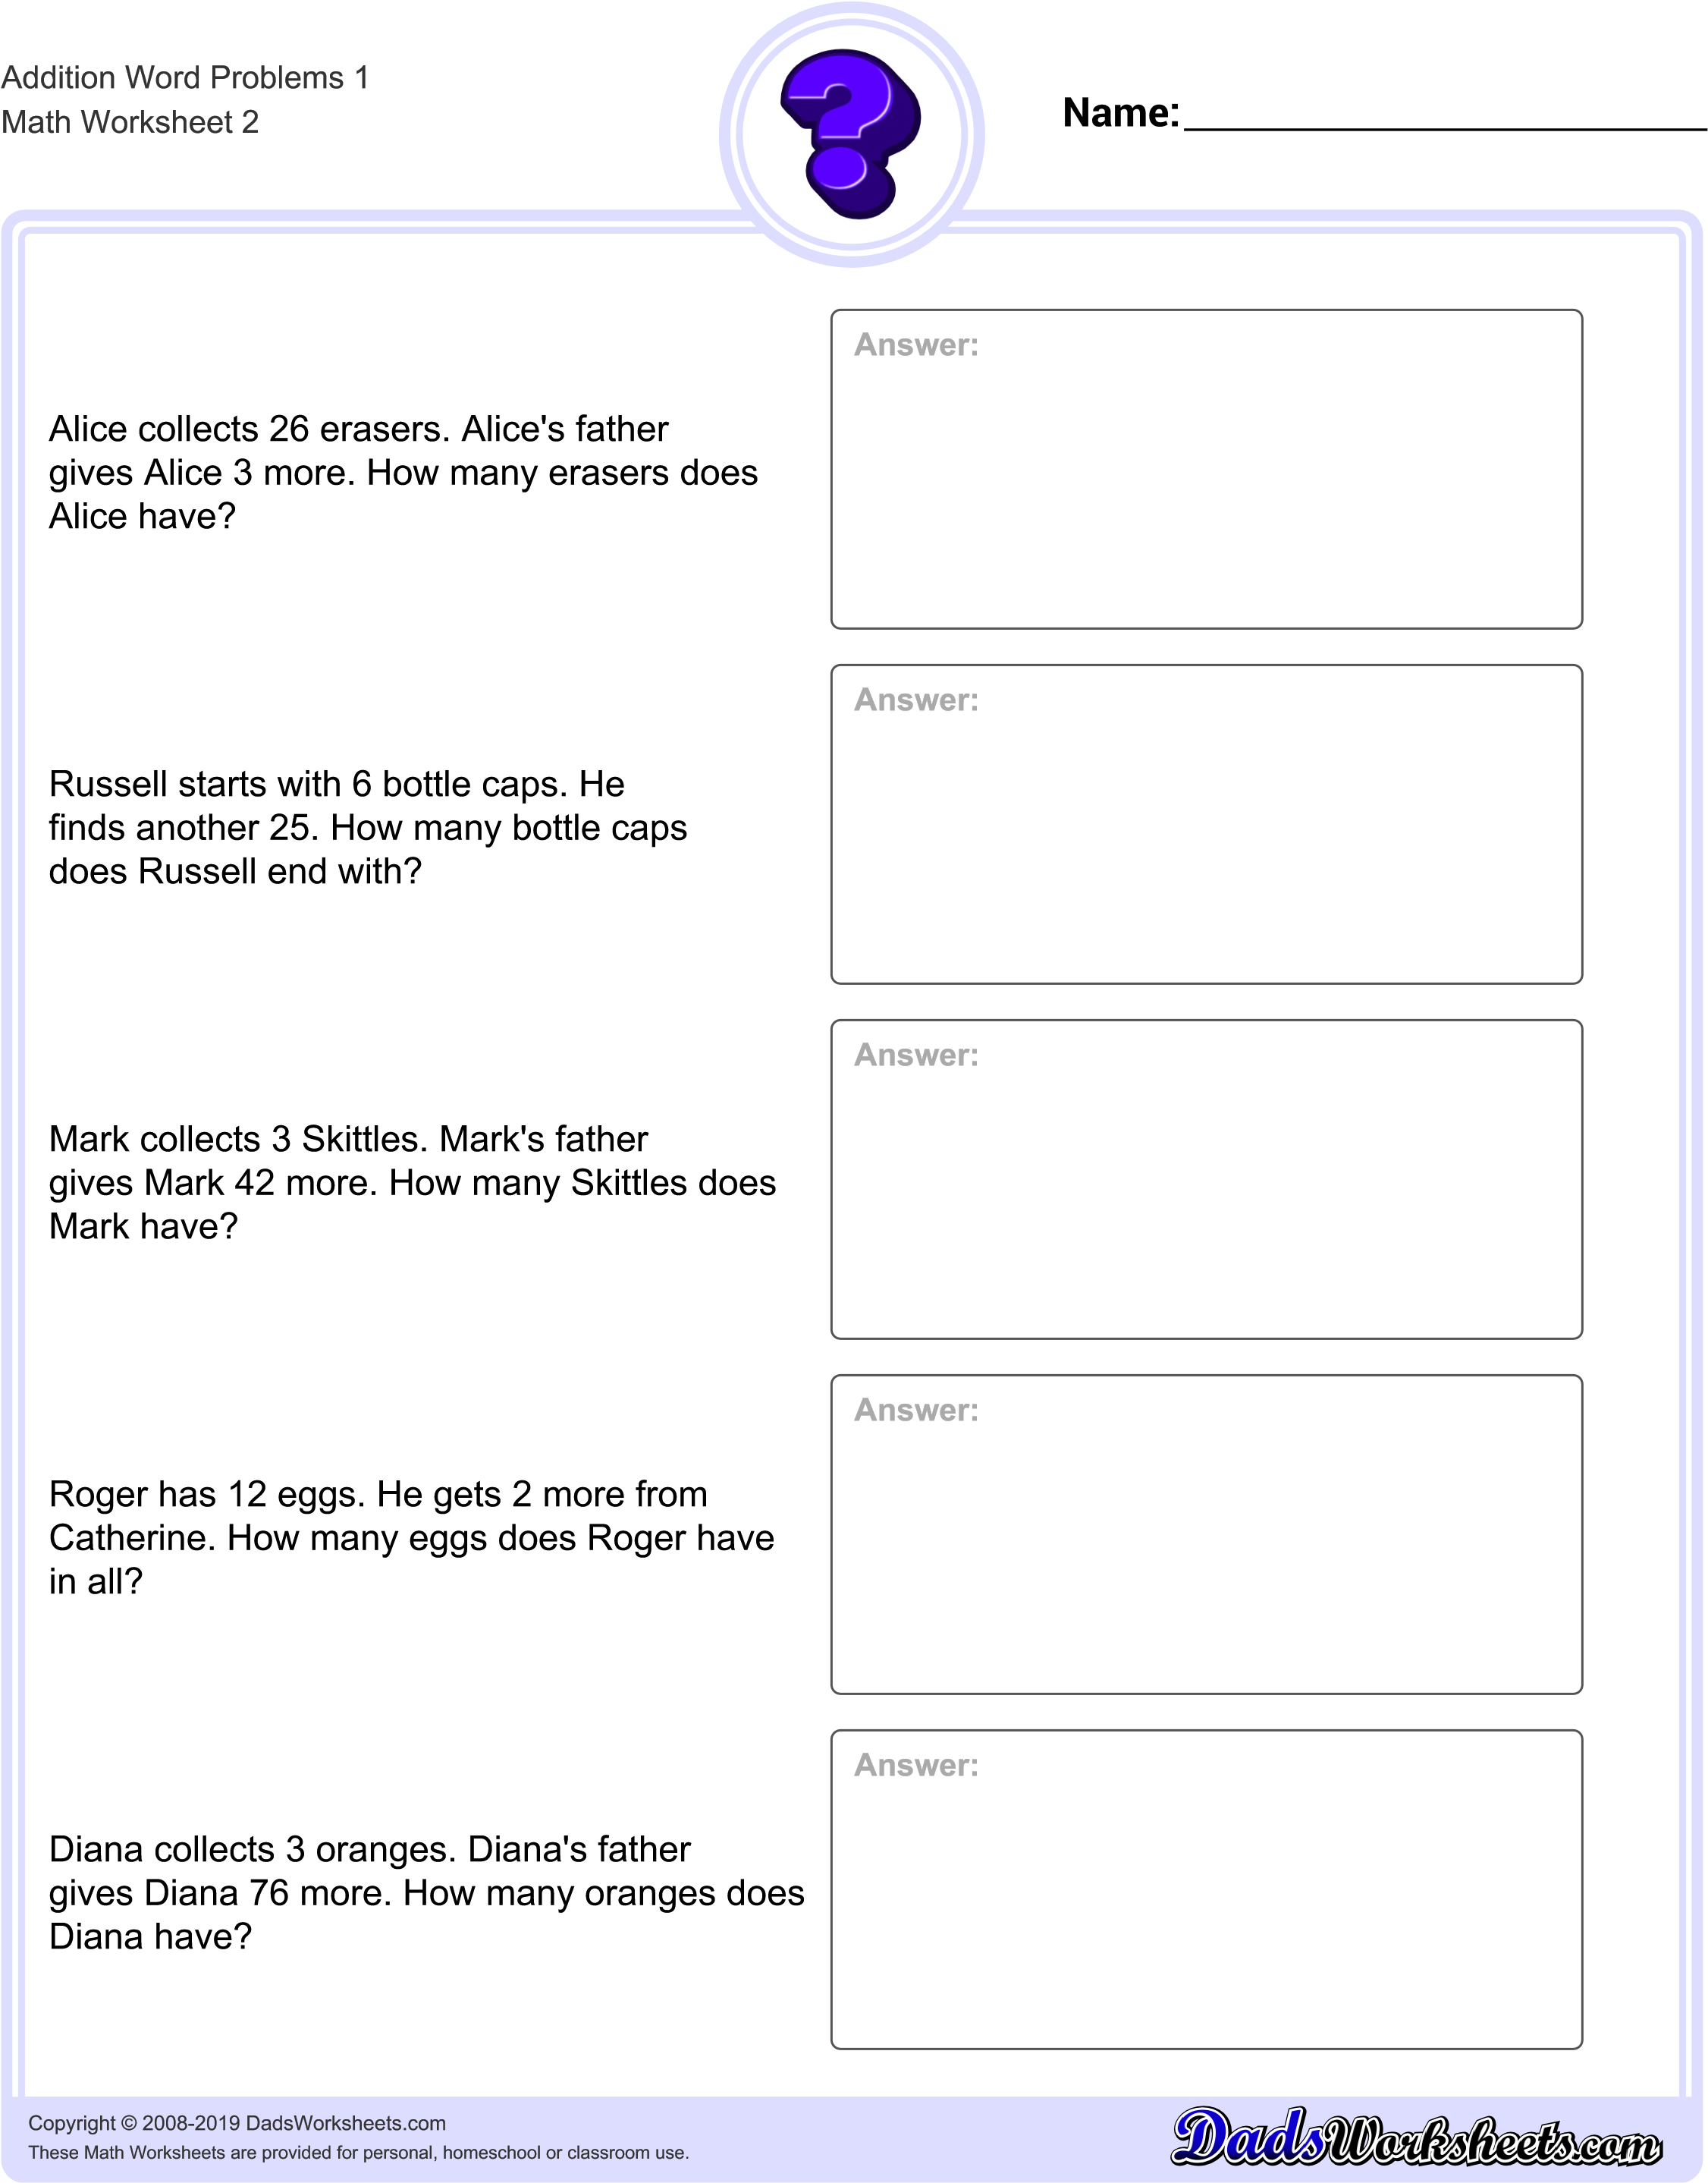
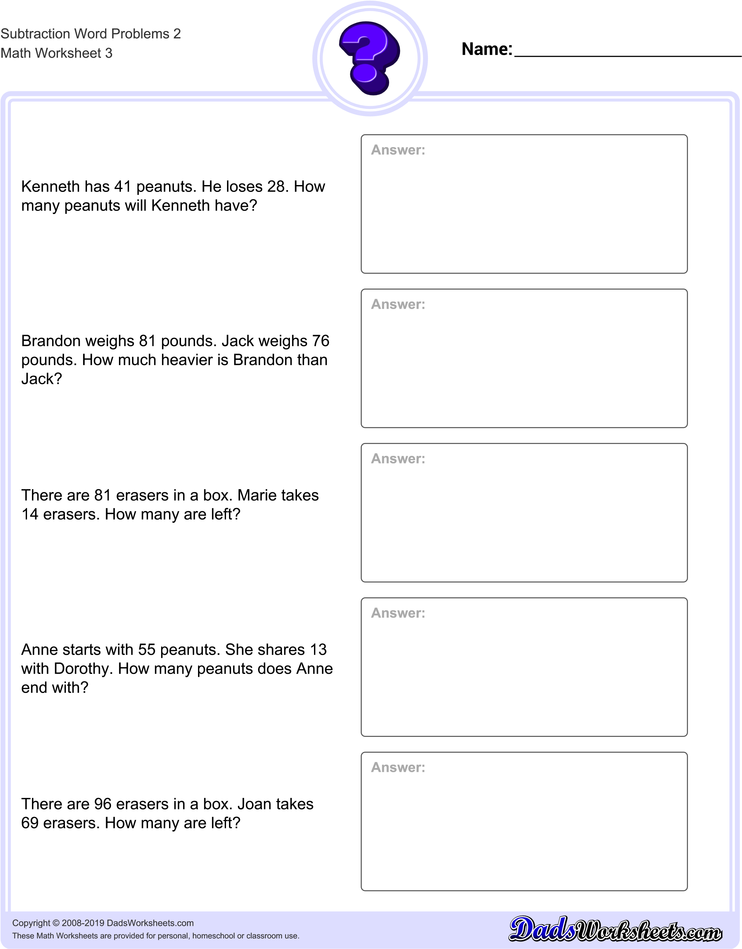
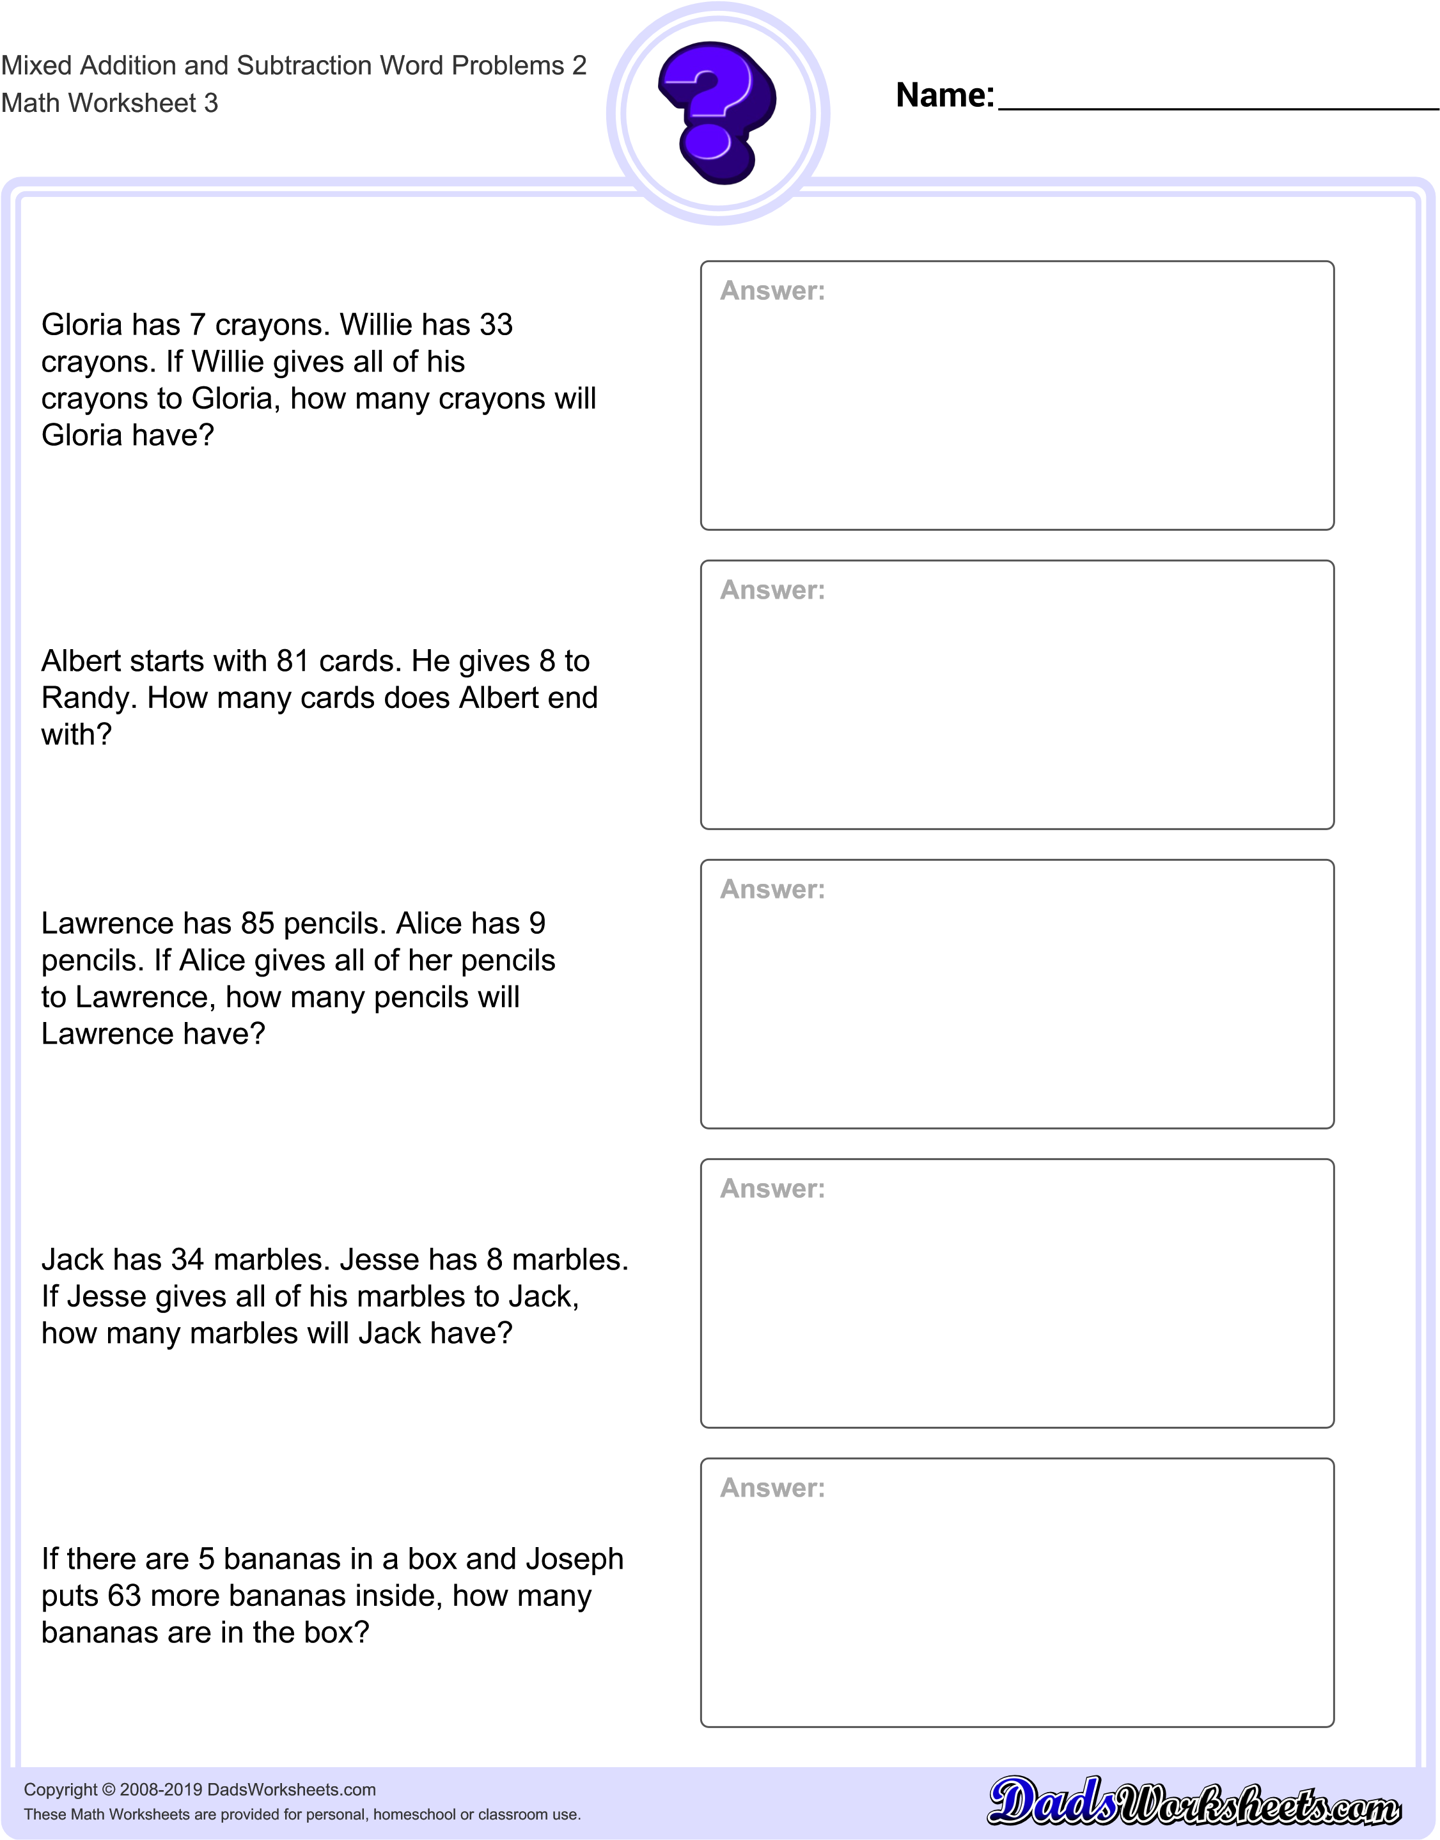
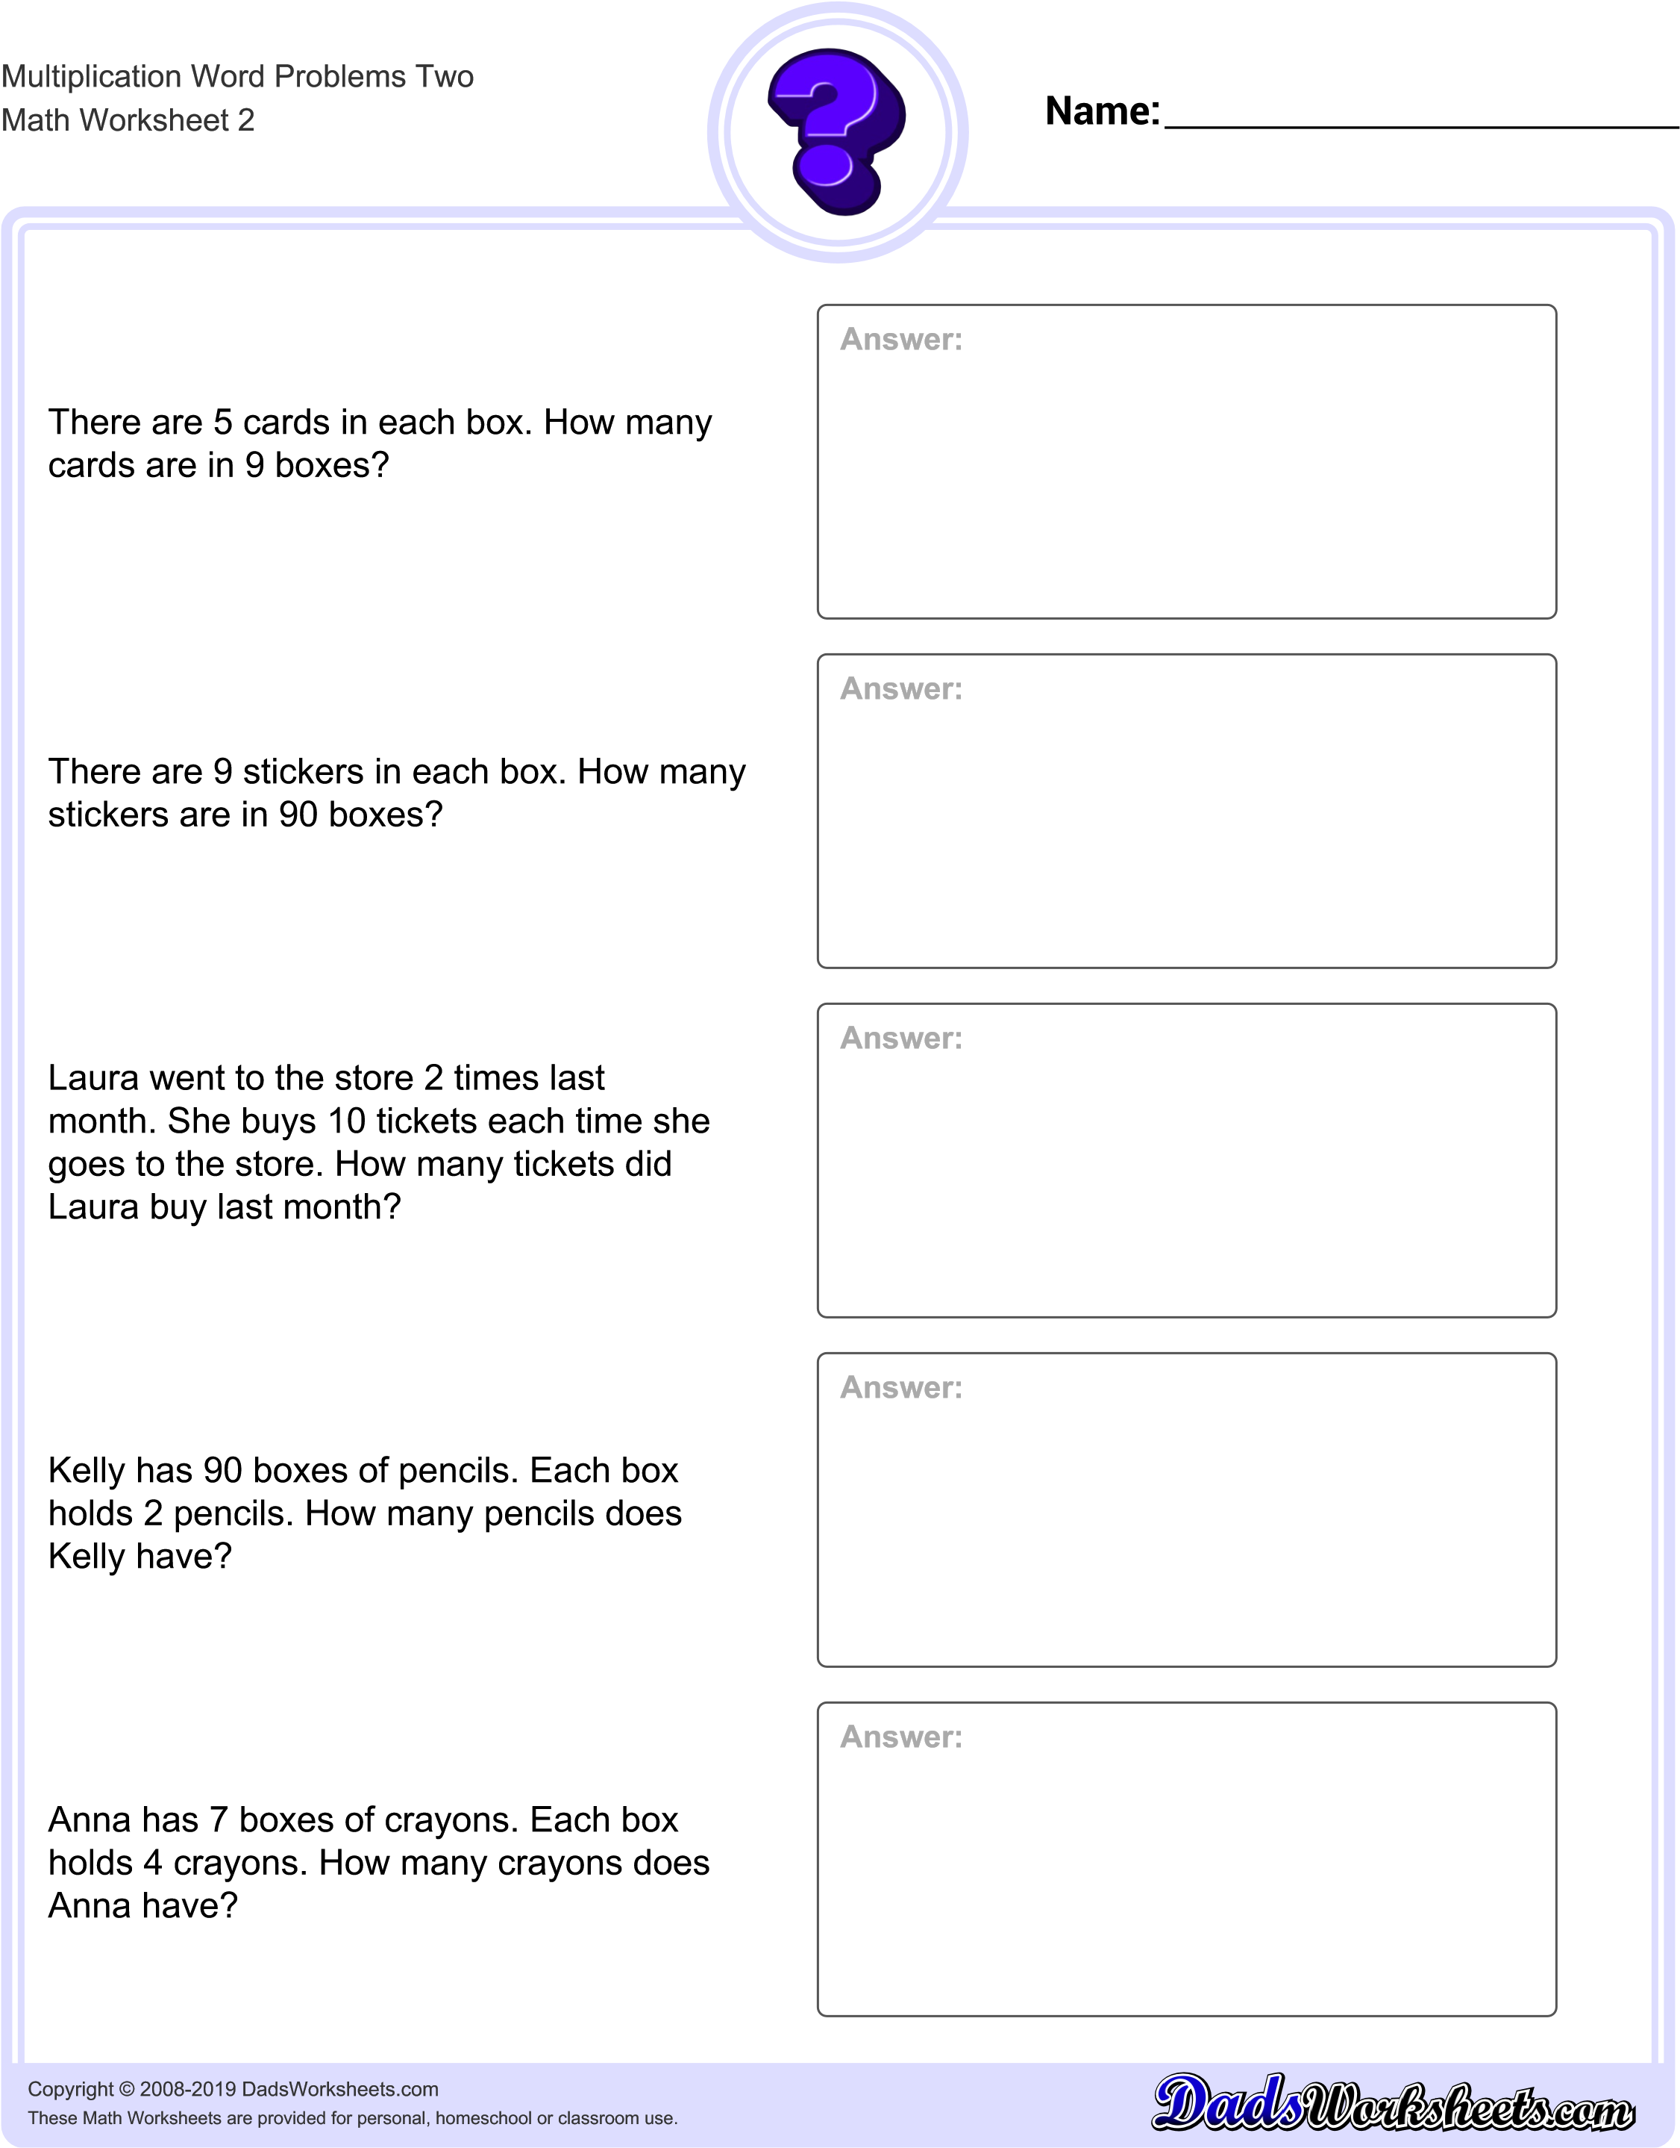
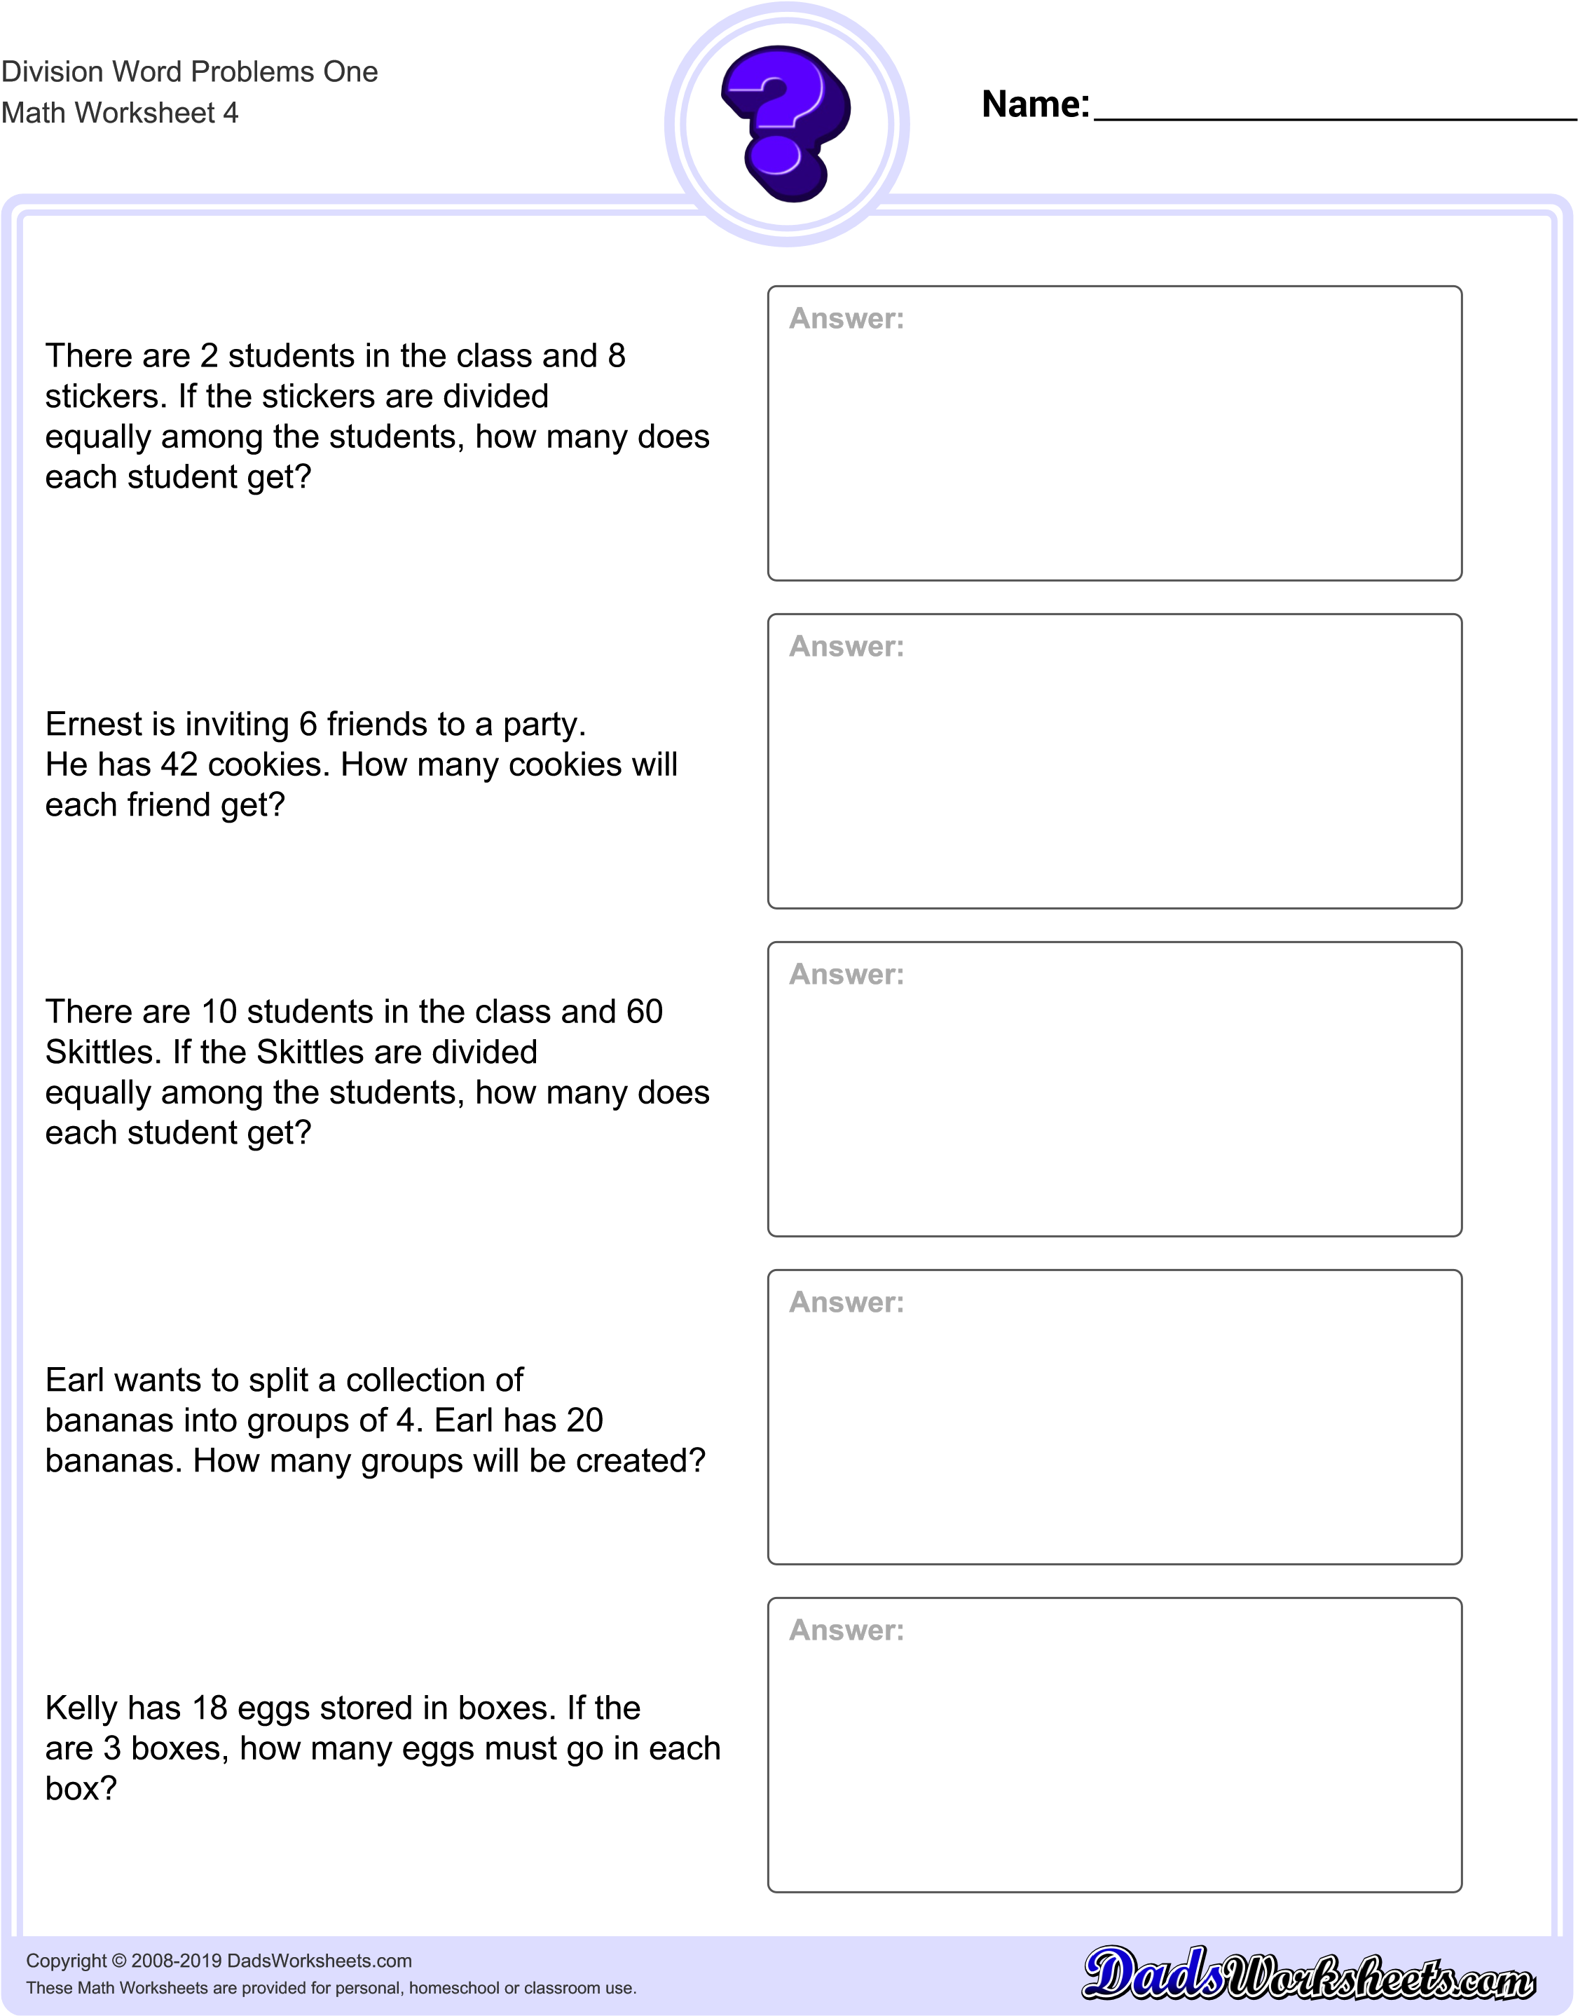
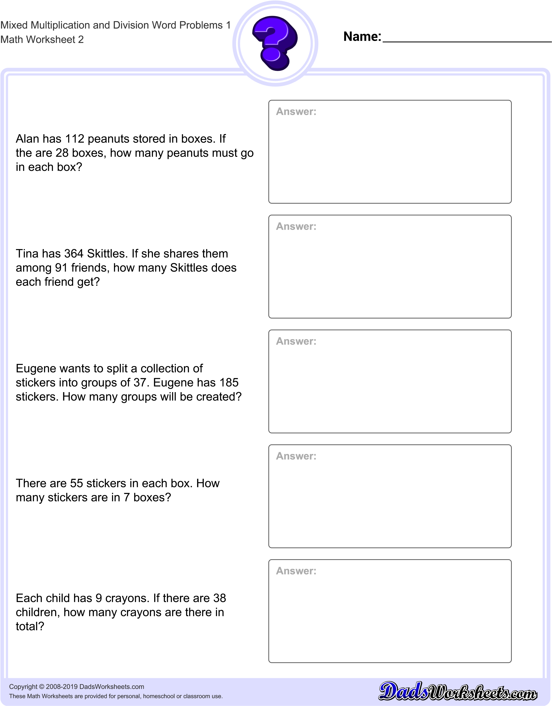
Addition  - Add  - All together  - And  - Both  - Combined  - How many in all  - How much  - In all  - Increased by  - More  - Plus  - Sum  - Together  - Total | Subtraction  - Change  - Decreased by  - Difference  - Fewer or fewer than  - how many are left or how many do they have left  - how many did not have  - how many more or how much more  - how much longer (shorter, heavier, taller)  - less or less than  - lost  - minus  - need to  - reduce  - remain  - Subtract  - Take away
Multiplication  - Double  - Each group  - Every  - Factor of  - Increased by  - Multiplied by  - Of  - Product  - Times  - Triple  - twice | - as much  - cut up  - each group has  - equal sharing  - half (or other fractions)  - how many in each  - parts  - per  - percent  - quotient of  - ratio of  - separated  - share something equally
Key Words in Math Problems
If you are stuck, look for these words to help you solve word problems.

