Week 2 Assignment 1
Directions: Watch the Khan Academy Video linked below and then answer the following questions on supply. STOP when the video starts discussing market equilibrium. If you cannot watch the video, use your textbook or lecture notes instead. Do the assignment on binder paper.
- https://www.khanacademy.org/economics-finance-domain/microeconomics/supply-demand-equilibrium/supply-curve-tutorial/v/law-of-supply

- What is the law of supply?

- Why does a change or shift in supply occur?

- Summarize each of the determinants of supply
- Government Tools
- Technology
- Prices of Resources
- Competition
- Producers expectations

- What is the difference between a change in the quantity supplied and a change in supply?
Week 2 Assignment 2
Module 2 Assignment 2
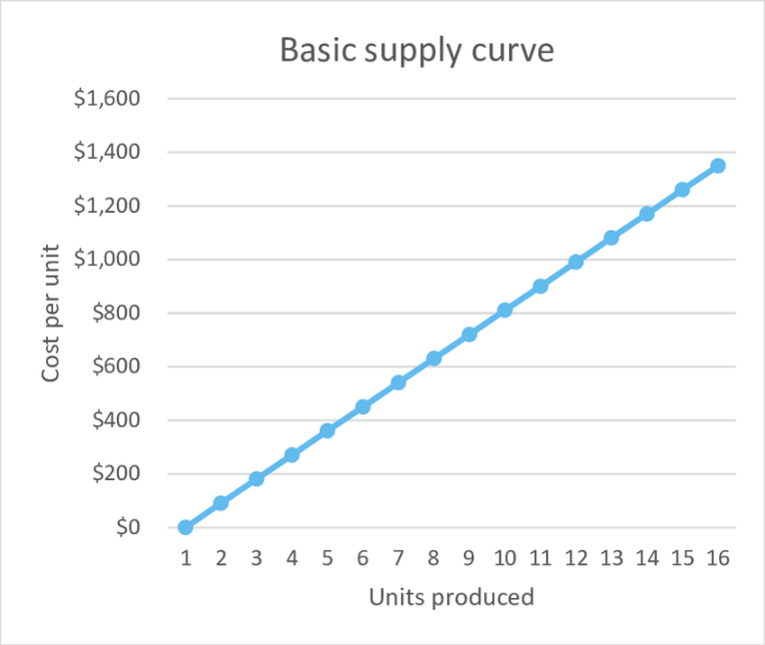
Directions: Determine how each of the following Scenarios will impact supply for the market indicated. Graph the shift on the graph, label each graph, identify the cause of the shift, and indicate if supply will increase, decrease or not change.
- Supply of bread.
A drought hits the Midwest and destroys 1/3 of wheat crops.
What is the cause of the determinant?
In which direction would the supply curve shift. Right or left? Why?

- Supply of Oil
Producers expect the price of oil increase decrease in six months.
What is the cause of the determinant?
In which direction would the supply curve shift. Right or left? Why
*Inserted as a visual reference

- Supply of Bicycles
New machinery cuts production time of bicycle chains in half.
What is the cause of the determinant?
In which direction would the supply curve shift. Right or left? Why?

- Supply of tractors
The second largest producer of tractors announces it is closing.
What is the cause of the determinant? Right or left? Why?

