THS Distance Learning - Spring 2020
THS Piano Classes & Choirs
Distance Learning Assignments
Mrs. Jennifer Grover
For: Piano Classes; periods 1 & 3
For: Choir Classes; periods 2, 4 & 5
Weeks 1-4

Contact information and officer hours
jgrover@tusd.net or Google Voice (209) 259-0312 (phone will be available only during temporary office hours: 10-1, Monday through Friday, from April 20 – Friday May 15) During these office hours, I am available for calls or texts, answering emails, remind messages, and zoom if you’d like to set up a face to face meeting.
Assignments
Beginning April 20, 2020, during the distance learning period, All students must complete and submit one of the following three assignment options each week for the next four weeks to Mrs. Grover by Friday, May 15, 2020 in order to receive course credit for fourth quarter and the Spring semester 2020; there will be no final exam.
Each week choose one of the following three assignment category options (these can be the same or different options each week – your choice) and then complete & submit each one by the weekly deadline; all assignments have an absolute deadline of Friday, May 15, 2020.
- OPTION “A” - PRACTICE CARD: https://tracyusd-my.sharepoint.com/:f:/g/personal/jgrover_tusd_net/EmWIyxQM66xAiGLtCwaC9eMBHrE0S60AAVTpITBY5226UA?e=oPFgKI
Complete & submit the weekly practice card, including a parent signature, demonstrating a minimum of 150 minutes of focused, individual practice per week.
- OPTION “B” - LISTENING LOG: https://tracyusd-my.sharepoint.com/:f:/g/personal/jgrover_tusd_net/Eh5TgumjqLFNtqw-4BjsF5wBkSlai3DmSgmmEXvm_6U2dA?e=aVUyjv
Complete & submit the weekly ranking form, listening to the required samples and writing the reviews and ranking activity.
- OPTION “C” - MUSIC APPRECIATION & THEORY BINGO CARD: https://tracyusd-my.sharepoint.com/:f:/g/personal/jgrover_tusd_net/EkVpzBa3SYBMvg6dM5pPoyAB4YHFLRTHwgEXHgDpnHXgxg?e=mfYg5H
Complete & submit the attached worksheet and prompts.
Accessing and submitting assignments in Options A, B, or C may be done digitally through the Microsoft OneDrive folder that I will send (see above links). This is the most preferable, efficient, economic method!
If digital distance learning is not an option, then submitting assignment Options A or C may be done on paper, receiving and returning the printed assignments in person at the Tracy High School office.

OPTION “A” - PRACTICE CARD

Piano students: If you have a piano at home
Choral students: If you have something specific that you want/need to learn. (Senior Recital as an example)
Complete & submit the weekly practice card, including a parent signature, demonstrating a minimum of 150 minutes of focused, individual practice per week. Complete & submit this form once each week:
- Week 1 (Monday April 20 – Sunday April 26)
- Week 2 (Monday April 27 – Sunday May 3)
- Week 3 (Monday May 4 – Sunday May 10)
- Week 4 (Monday May 11 – Friday May 15)
If you submit this form digitally, you will need to have your parent send a separate email/message to verify that you did do these activities. You will also need to send all your attachments to this document in your OneDrive folder. https://tracyusd-my.sharepoint.com/:f:/g/personal/jgrover_tusd_net/EmWIyxQM66xAiGLtCwaC9eMBHrE0S60AAVTpITBY5226UA?e=GcIvWB
- Download and save the document under your name.
- Submit into the BINGO folder at the top of this document.
If you are submitting this as a hard copy to the school, you will need a clean copy for the next week.

Student Name: Teacher Name:

Class (Piano or Choir): Period: Week #:

Practice Log (record total, daily minutes of focused, individual practice time):
 | DATE | MINUTES | PARENT SIGNATURE
Monday
Tuesday
Wednesday
Thursday
Friday
Saturday (OPTIONAL)
Sunday (OPTIONAL)

TOTAL MINUTES (minimum of 150min/wk):
OPTION “B” – TOURNAMENT OF CHAMPIONS LISTENING LOG

This is a tournament type bracket where you will rank and choose your favorite musical selection to “vote” for an overall “winner”. You will complete & submit a different section of the ranking form each week. I will count the “votes” and keep a “Master Bracket” for the whole group. As you listen to the required samples, you will write a justification for each of your “votes”. The competition brackets and “voting” form/questionnaire will be published through the OneDrive link here: https://tracyusd-my.sharepoint.com/:f:/g/personal/jgrover_tusd_net/Eh5TgumjqLFNtqw-4BjsF5wBkSlai3DmSgmmEXvm_6U2dA?e=aVUyjv
You will also submit the completed forms through the OneDrive Folders.
Piano Classes: Piano specific listening examples in one of the four quadrants
Choir Classes: Choral listening examples in four categories
- Week 1 (Monday April 20 – Sunday April 26): Choirs: “Spirituals”. Piano: Top left section
- Week 2 (Monday April 27 – Sunday May 3): Choirs: “Secular”. Piano: Bottom left section
- Week 3 (Monday May 4 – Sunday May 10): Choirs: “Sacred”. Piano: Top right section
- Week 4 (Monday May 11 – Friday May 15): Choirs: “Foreign Language”. Piano: Bottom Right section. Finally, select an overall winner comparing all four sections. Once I’ve received all the “votes”, I will declare the overall champion.
If you are doing the paper only version, you will need to fill in the voting form each week and then write your justifications on a separate piece of paper. Then, you will need to turn in your work each week. You can keep your tournament bracket until the very end, then turn it in on the last week.

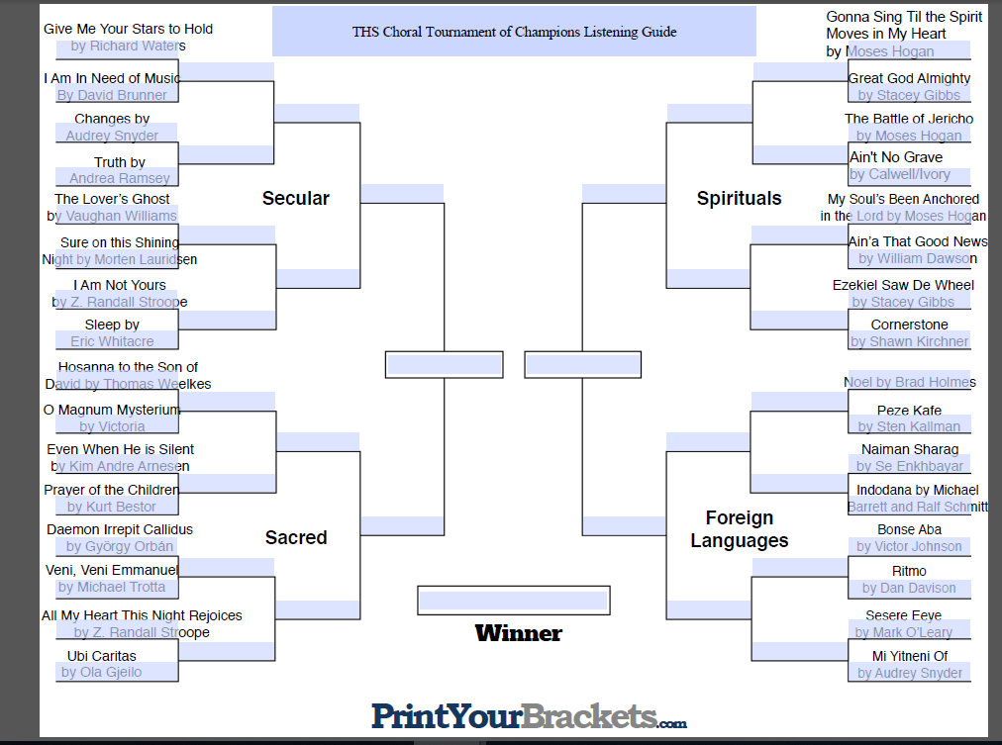
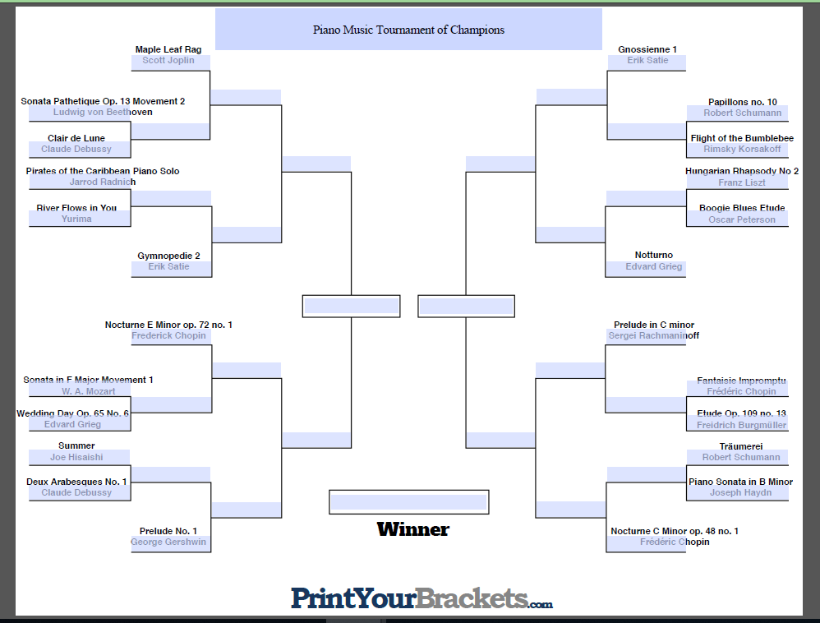
Piano Links
Title | Composer | Link
Sonata Pathetique Mov.3 | Ludwig Von Beethoven | https://www.youtube.com/watch?v=BuN3yCmHb_U
Clair De Lune | Claude Debussy | https://www.youtube.com/watch?v=JVmwLJeeOy4
Pirates of the Caribbean | Jarrod Radnich | https://www.youtube.com/watch?v=n4JD-3-UAzM
River Flows in You | Yiruma | https://www.youtube.com/watch?v=7maJOI3QMu0
Maple Leaf Rag | Scott Joplin | https://www.youtube.com/watch?v=pMAtL7n_-rc
Gymnopedies | Erik Satie | https://www.youtube.com/watch?v=_fuIMye31Gw
Sonata in F Major Mov. 1 | J. S. Mozart | https://www.youtube.com/watch?v=eY2ZOc8oFlM
Wedding Day at Troldhaugen | Edvard Grieg | https://www.youtube.com/watch?v=WVra2IotK-M
Summer | Joe Hisaishi | https://www.youtube.com/watch?v=J7or0noYfMA
Deux Arabesque No. 1 | Claude Debussy | https://www.youtube.com/watch?v=9Fle2CP8gR0
Nocturne in E Minor | Frederic Chopin | https://www.youtube.com/watch?v=Wx0jkZdQwN8
Prelude No. 1 | George Gershwin | https://www.youtube.com/watch?v=iggW4OvS-58
Papillons No. 10 | Robert Schumann | https://www.youtube.com/watch?v=-sGkTY8eG5Y
Flight of the Bumblebee | Rimsky-Korsakov | https://www.youtube.com/watch?v=-sGkTY8eG5Y
Hungarian Rhapsody No. 2 | Franz Fliszt | https://www.youtube.com/watch?v=LdH1hSWGFGU
Boogie Blues Etude | Oscar Peterson | https://www.youtube.com/watch?v=xdd5pn1xs7M
Notturno | Edvard Grieg | https://www.youtube.com/watch?v=_dDz-bvV2DM
Fantaisie Impromptu in C# Minor | Frederic Chopin | https://www.youtube.com/watch?v=Gy5UHK4EeM8
Etude Op. 109 No. 13 | Freidrich Burgmuller | https://www.youtube.com/watch?v=RlIBXfVTjxo
Traumerei | Robert Schumann | https://www.youtube.com/watch?v=9zVQk0YviAA
Prelude in C# Minor | Sergei Rachmaninoff | https://www.youtube.com/watch?v=3IlDxUyQVB0
Nocturne in C Minor Op 48 No. 1 | Frederic Chopin | https://www.youtube.com/watch?v=vAnLEYLyGXw

Choral Links
Title | Style | Composer | Link
Gonna Sing 'Til The Spirit Moves Me | Spiritual | Moses Hogan | https://www.youtube.com/watch?v=ljeVSYh-PV4
Great God Almighty | Spiritual | Stacey Gibbs | https://www.youtube.com/watch?v=xJNN5bc66Gc
Battle of Jericho | Spiritual | Moses Hogan | https://www.youtube.com/watch?v=XSnplmdfAVo
Ain't No Grave Gonna Hold My Body Down | Spiritual | Caldwell & Ivory | https://www.youtube.com/watch?v=WiV3gI1cGHM
My Soul's Been Anchored in the Lord | Spiritual | Moses Hogan | https://www.youtube.com/watch?v=SpHCwl2NCVI
Ain'-a That Good News | Spiritual | William Dawson | https://www.youtube.com/watch?v=ZKGNhSf3G-c
Ezekiel Saw the Wheel | Spiritual | Stacey Gibbs | https://www.youtube.com/watch?v=0gdbKiNDnt0
Cornerstone | Spiritual | Shawn Kirchner | https://www.youtube.com/watch?v=uOm5PfiCGM8
Give Me Your Stars to Hold | Secular | Richard Waters | https://www.youtube.com/watch?v=zQQBvvU35KU
I Am in Need of Music | Secular | David Brunner | https://www.youtube.com/watch?v=PHsTAtfsUac
Changes | Secular | Audrey Snyder | https://www.youtube.com/watch?v=3nNOvuDbeAE
Truth | Secular | Andrea Ramsey | https://www.youtube.com/watch?v=uXAgTLoNKXI
The Lover's Ghost | Secular | Vaughan Williams | https://www.youtube.com/watch?v=wWcW1c-Q2mg
Sure on This Shining Night | Secular | Morten Lauridsen | https://www.youtube.com/watch?v=UwxlMvV6LkE
I Am Not Yours | Secular | Randall Stroope | https://www.youtube.com/watch?v=6cUbI8ibYZo
Sleep | Secular | Eric Whitacre | https://www.youtube.com/watch?v=Yw5gupbe9E0
Hosanna to the Son of David | Sacred | Thomas Weelkes | https://www.youtube.com/watch?v=FC2WTqIbp5Y
O Magnum Mysterium | Sacred | Tomas Victoria | https://www.youtube.com/watch?v=MRPEJkoEstc
Even When He is Silent | Sacred | Kim Andre Arnesen | https://www.youtube.com/watch?v=MxFYTS1cpks
Prayer of the Children | Sacred | Kurt Bestor | https://www.youtube.com/watch?v=r9x6hSdRAvI
Daemon Irrepit Callidus | Sacred | Orban Gyorgy | https://www.youtube.com/watch?v=cLDuO3j319s
Veni Veni Emmanuel | Sacred | Michael John Trotta | https://www.youtube.com/watch?v=j0FO2uXSWKk
All My Heart This Night Rejoices | Sacred | Randall Stroope | https://www.youtube.com/watch?v=Q6z-ftmT4D8
Ubi Caritas | Sacred | Ola Gjeilo | https://www.youtube.com/watch?v=Xp3IHBSyZKY
Noel | Languages | Brad Holmes | https://www.youtube.com/watch?v=AGSyrgXjSeU
Peze Kafe | Languages | Sten Kallman | https://www.youtube.com/watch?v=0FIWpI6lWuU
Naiman Sharag | Languages | Se Enkhbayar | https://www.youtube.com/watch?v=6ZFWsEMcyB0
Indodana | Languages | Barrett and Schmitt | https://www.youtube.com/watch?v=jMuwg0zE_o4
Bonse Aba | Languages | Victor Johnson | https://www.youtube.com/watch?v=US_oTqmiEVM
Ritmo | Languages | Dan Davison | https://www.youtube.com/watch?v=sI_kNx9C5Bo
Sesere Eeye | Languages | Mark O'Leary | https://www.youtube.com/watch?v=VAio96oJnQ0
Mi Yitmeni Of | Languages | Audrey Snyder | https://www.youtube.com/watch?v=vtIzUcTOWKI

OPTION “C” - MUSIC APPRECIATION & THEORY BINGO CARD
(Digital or Paper Only Access)

Spring Music Challenge
Rules: You have 4 weeks to complete square and get as many signatures on your bingo card as possible. (You must get a signature from a parent/guardian to verify completion) A regular “BINGO” (Vertical/Diagonal/Horizontal) earns 50 points. A “BLACKOUT” (all boxes have a signature) earns 400 points. Squares signed more than once will earn an extra 10 points each.
When you are asked to list, draw or write something down, do so on a separate piece of paper and attach it to this BINGO card.
You may turn this in once a week or at the end of the four-week period – no later than May 15th.
If you submit this form digitally, you will need to have your parent send a separate email/message to verify that you did do these activities. You will also need to send all your attachments to this document in your OneDrive folder. https://tracyusd-my.sharepoint.com/:f:/g/personal/jgrover_tusd_net/EkVpzBa3SYBMvg6dM5pPoyAB4YHFLRTHwgEXHgDpnHXgxg?e=mfYg5H
- Download and save the document under your name.
- Go to BINGO folder link at the top of this document.
- Create a new folder with you name and drop all your documentation into that folder.

If you are submitting this as a hard copy to the school each week, you will need a clean copy for the next week.

Name:___________________ Class: ________________ Period:_____ Teacher:__________________ Wk#: ______

B | I | N |  | G |  | O
Write a short essay about your favorite musician or genre. | Explore one of your parent’s favorite songs. Have them tell you why they like that song. Write down their response. | Clap the rhythm of any song. Clap it for someone and see if they can identify it. Try you can write down. | Explore music in nature! Write down a list of sounds you hear as you take a walk outside. Attach it to this form. |  | Create a piece of art while listening to music.
Learn to play/sing a new song from a movie, TV show or video game. | Perform for your pets, if you don’t have a pet, play for your favorite stuffed animal | Practice anything musical for 20 minutes | Call a relative/friend and play/sing them your favorite song |  | Create your own instrument to play
Write down 3 important things you use for good technique. Why are they important? | Close your eyes and listen to music a cartoon or movie. Can you tell what is happening? How does it make you feel? | Free Space | Have a Dance party |  | Write your parent/guardian a thank you note for letting you make music in the home.
Create a playlist of music that makes you happy. | Create a rhythm pattern. Write it down. Practice clapping it. | Make a list of every style of music you hear as you watch TV in one day. Did you hear anything surprising? | Create an album cover for your imaginary music album. |  | Listen to the music during the credits of a movie. Write down as many elements of music that you can hear.
With your family, make a list of as many musicians or groups from the last 100 years as you can. | Sing while doing chores | Perform for your family | Write down a music goal you have for yourself |  | Explain to a family member the proper technic for your instrument.

