Cold War Political Cartoons

Directions: Analyze the following political cartoons and answer the questions. This assignment is OPTIONAL and will NOT be graded.
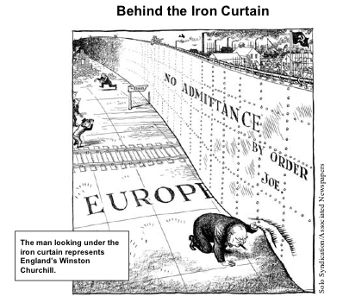
Study the political cartoon and answer the questions below.
- Notice the “No Admittance by order Joe” sign on the Iron Curtain? Who is Joe and what country does he represent?
- Why do you think Winston Churchill is peeping under the Iron Curtain?
- Why do you think train tracks are being cut off at the iron curtain?
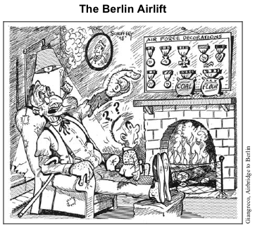
Study the political cartoon and answer the questions below.
- What do the medals coal and flour represent?
- Why do you think the artist shows the coal and flour medals being as important as the other medals?
- How might a West Berliner have felt when they saw the planes of the Berlin Airlift coming to deliver supplies?

